IAPB MEMBERS SURVEY 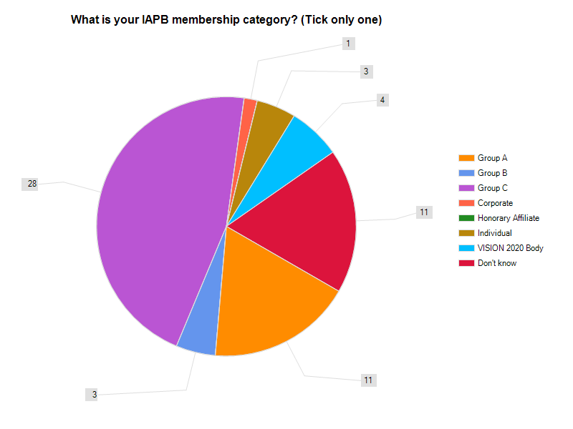
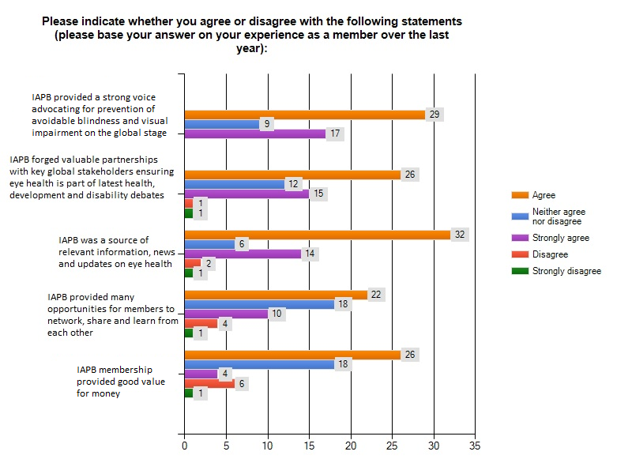
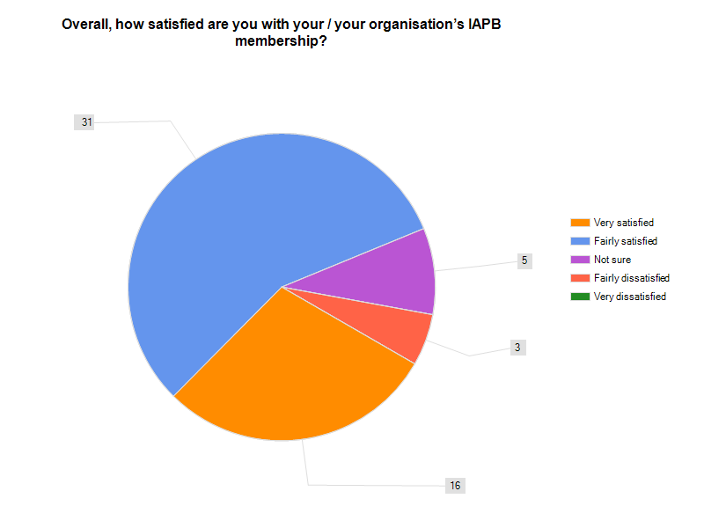
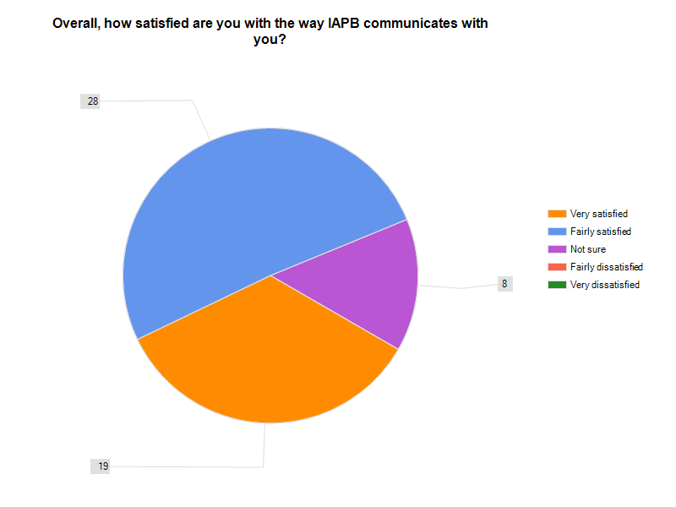

Council of Members Meeting Format

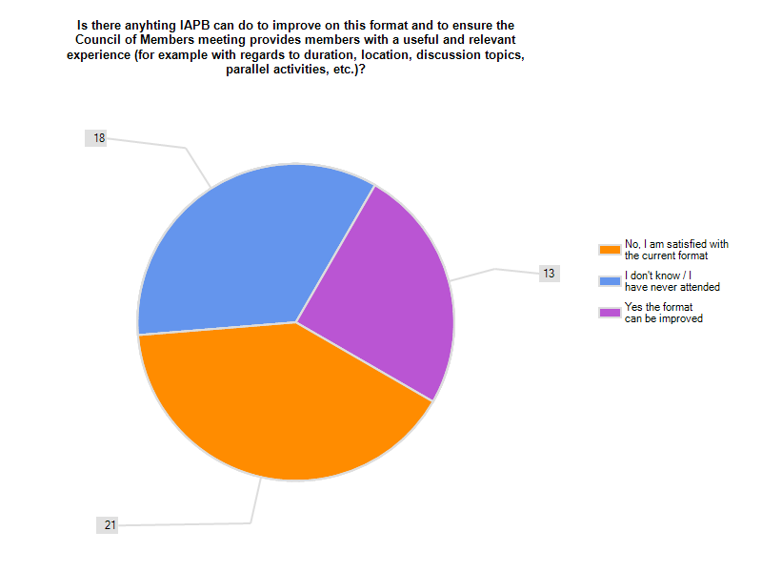
Council of Members meeting format – a summary of open answers:
- More focus on how members can work together to achieve common goals, with discussions leading to plans and action, not just discussion.
- Organise fora for developed world issues which may bring interest and support from other global players.
- Structured for more communication among members; less hearing from the podium.
- The IAPB committees meet during the CoM meetings. It would be nice if they would have open sessions of CoM members, especially Group C members, could participate, at least as observers in these mostly closed committees.
- This is already improving, but still feels a bit repetitive if you are a BOT member. I would like to see IAPB providing more position papers (eg on cataract surgeons) and guidelines (the RE one was good). This might mean working groups - which I know became turgid in the past.
- Focus on strategic issues and get buy in if possible and then move from there. Pick 2 to 4 major priorities and focus the strength of the group on them.
- Can have multiple meeting sites.
- The information part is ok but maybe too little interaction between members and maybe some more information sharing.
- I believe we could be more interactive than just 'reporting'. When we have had strategic planning sessions such as in Melbourne and India, I felt our input was heard.
- It would be worthwhile to have some technical/scientific sessions that can further the members work through deeper understanding of new trends, opportunities, etc.
- Video streaming would be beneficial. it seems that same organisations seem to be represented.
- Link to regional initiatives, facilitate learning and knowledge sharing, dialogue on focus issues rather than information dissemination (thematic seminars?), drawing on members experience and expertise (involving).

