The Global Burden of Disease (GBD) 2010 Study
November 2014

The purpose of IAPB Briefing Papers is to inform IAPB members and others about important and emerging issues affecting the elimination of avoidable blindness and visual impairment.
By Professor Rupert Bourne and Peter Ackland
The work of the GBD Vision Loss Expert Group provides estimates of the global number of blind and vision impaired persons over the period 1990 to 2010. The purpose of this paper is to clarify how both the absolute numbers and prevalence have changed over this time.
Purpose of this paper

The eye health community now has two sets of global estimates on the magnitude, prevalence and causes of blindness (<3/60 in the better eye) and Moderate & Severe Visual Impairment (MSVI <6/18 to ≥3/60). Over the years (1995; 2002/4 and 2010) estimates have come from the prevention of blindness and deafness (PBD) team at WHO. Recently, the Global Burden of Disease (GBD) Vision Loss Expert Group has also produced detailed estimates for both 1990 and 2010 by creating and analyzing a database of available data from 1980 to 2012 (the “Global Vision Database”).

A comparison of the findings of the two sets of data for 2010 and the different methodologies used to develop the estimates has already been made in another IAPB Briefing paper prepared by Dr Kate Taylor http://www.iapb.org/sites/iapb.org/files/IAPB%20position%20on%20GBD%20data.pdf

The purpose of this paper is to clarify what the GBD estimates tell us about how the total number of blind and MSVI persons has changed over a period of 20 years from 1990. It will also look at changes in prevalence rates.

Comparing global numbers from the 1995 and 2002/4 PBD studies with data from the GBD 2010 data set is strongly discouraged, because the methodologies are different; it is akin to comparing apples and oranges and can give rise to spurious numbers and claims.

Within the PBD set of data the methodology used to model the estimates was modified over the years and PBD has always made it clear that because of this, and an increase in the number of surveys from which to model estimates, that the data from the various PBD analyses cannot be compared over time (though inevitably people have done so). However the GBD data set does apply the same modelling across the different years – thus it is the most reliable data source in terms of showing changes over time.

The GBD data is a “very good news story” – but it does need to be communicated properly.

The number of blind people and how this has changed between 1990 and 2010.

The absolute number of blind people in the world has not changed over the 20 year period, indeed it has remained constant. This is shown in Table 1, which also includes the upper and lower end of the range based upon 95% confidence limits.

Table 1 The global number of blind persons in five yearly intervals - 1990 to 2010

Year | Global number (all ages) affected by blindness
Year | Mean  Prevalence | 95% CI (Lower limit) | 95% CI (Upper limit)
1990 | 31,815,900 | 28,143,000 | 36,744,900
1995 | 32,106,360 | 29,046,160 | 35,538,360
2000 | 32,191,200 | 29,529,000 | 35,043,120
2005 | 32,214,000 | 29,406,000 | 35,366,500
2010 | 32,410,560 | 29,351,400 | 36,523,890

At first glance this may appear as “disappointing” and hardly a good news story. However over the 20 year period two very important demographic changes have occurred, both of which would have been expected to give rise to a major rise in the absolute number of blind persons:
- The global population has increased.
- The world population has aged and the proportion of total population over 50 years old has also increased.

The fact that the absolute numbers of blind people have not gone up and remained more or less constant indicates an extremely encouraging trend.

The GBD data also gives figures for those with MSVI and the estimates were a total of 172m in 1990 rising to 191m in 2010, but again considerably less of an increase than one would have estimated based on an ageing and increasing population demographic.

The GBD data also estimated that 176 million people had mild vision impairment (<6/12 to 6/18 in the better eye), in 2010.

The Good News Story: Part 1

The GBD Vision Loss Group estimated how many blind and MSVI people one may have expected in 2010, based on 1990 prevalence and modelling for the increased and ageing population. Table 2 shows what we may have expected in 2010 for both blindness and MSVI compared with the actual numbers.

Table 2 Actual global numbers compared with predicted numbers.

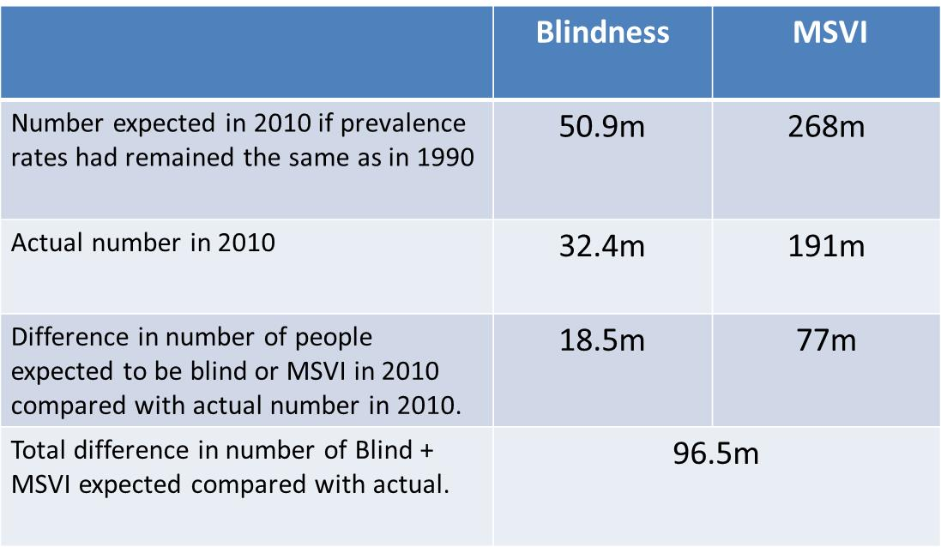

Thus, in the year 2010 there were some 18.5m blind people and 77m MSVI persons less than would have been expected if prevalence had not improved – a total of just under 100m people fewer.

The Good News Story: Part 2

The best way to compare changes in prevalence rates over time is to look at age-standardised prevalence rates. Age-standardisation against a reference population, in this case the WHO reference population, allows one to compare the prevalence between the 1990 and 2010 time points by “ironing out” change in demographic profiles over the years. The GBD estimates set out age-standardised prevalence rates for the whole population (i.e. all ages) and for the population 50 years of age and older.

Tables 3 and 4 and Figs 1 and 2 summarise the changes in the age-standardised prevalence of blindness over the 1990-2010 period at a global level and for different regions of the world:

Table 3 The age-standardised prevalence rates of blindness for all ages over time for the world and for regions.

Year | World | East & South –East Asia | High Income Countries | Latin America | North Africa + Middle East | South & Central Asia | Sub Saharan Africa
1990 | 0.60% | 0.57% | 0.30% | 0.50% | 0.99% | 0.80% | 0.80%
1995 | 0.56% | 0.53% | 0.30% | 0.50% | 0.91% | 0.80% | 0.73%
2000 | 0.53% | 0.49% | 0.20% | 0.40% | 0.83% | 0.70% | 0.68%
2005 | 0.50% | 0.45% | 0.20% | 0.40% | 0.76% | 0.70% | 0.62%
2010 | 0.47% | 0.43% | 0.20% | 0.40% | 0.70% | 0.60% | 0.56%

Fig 1 The change in age standardised prevalence rates of blindness for all ages over time for the world and for regions.
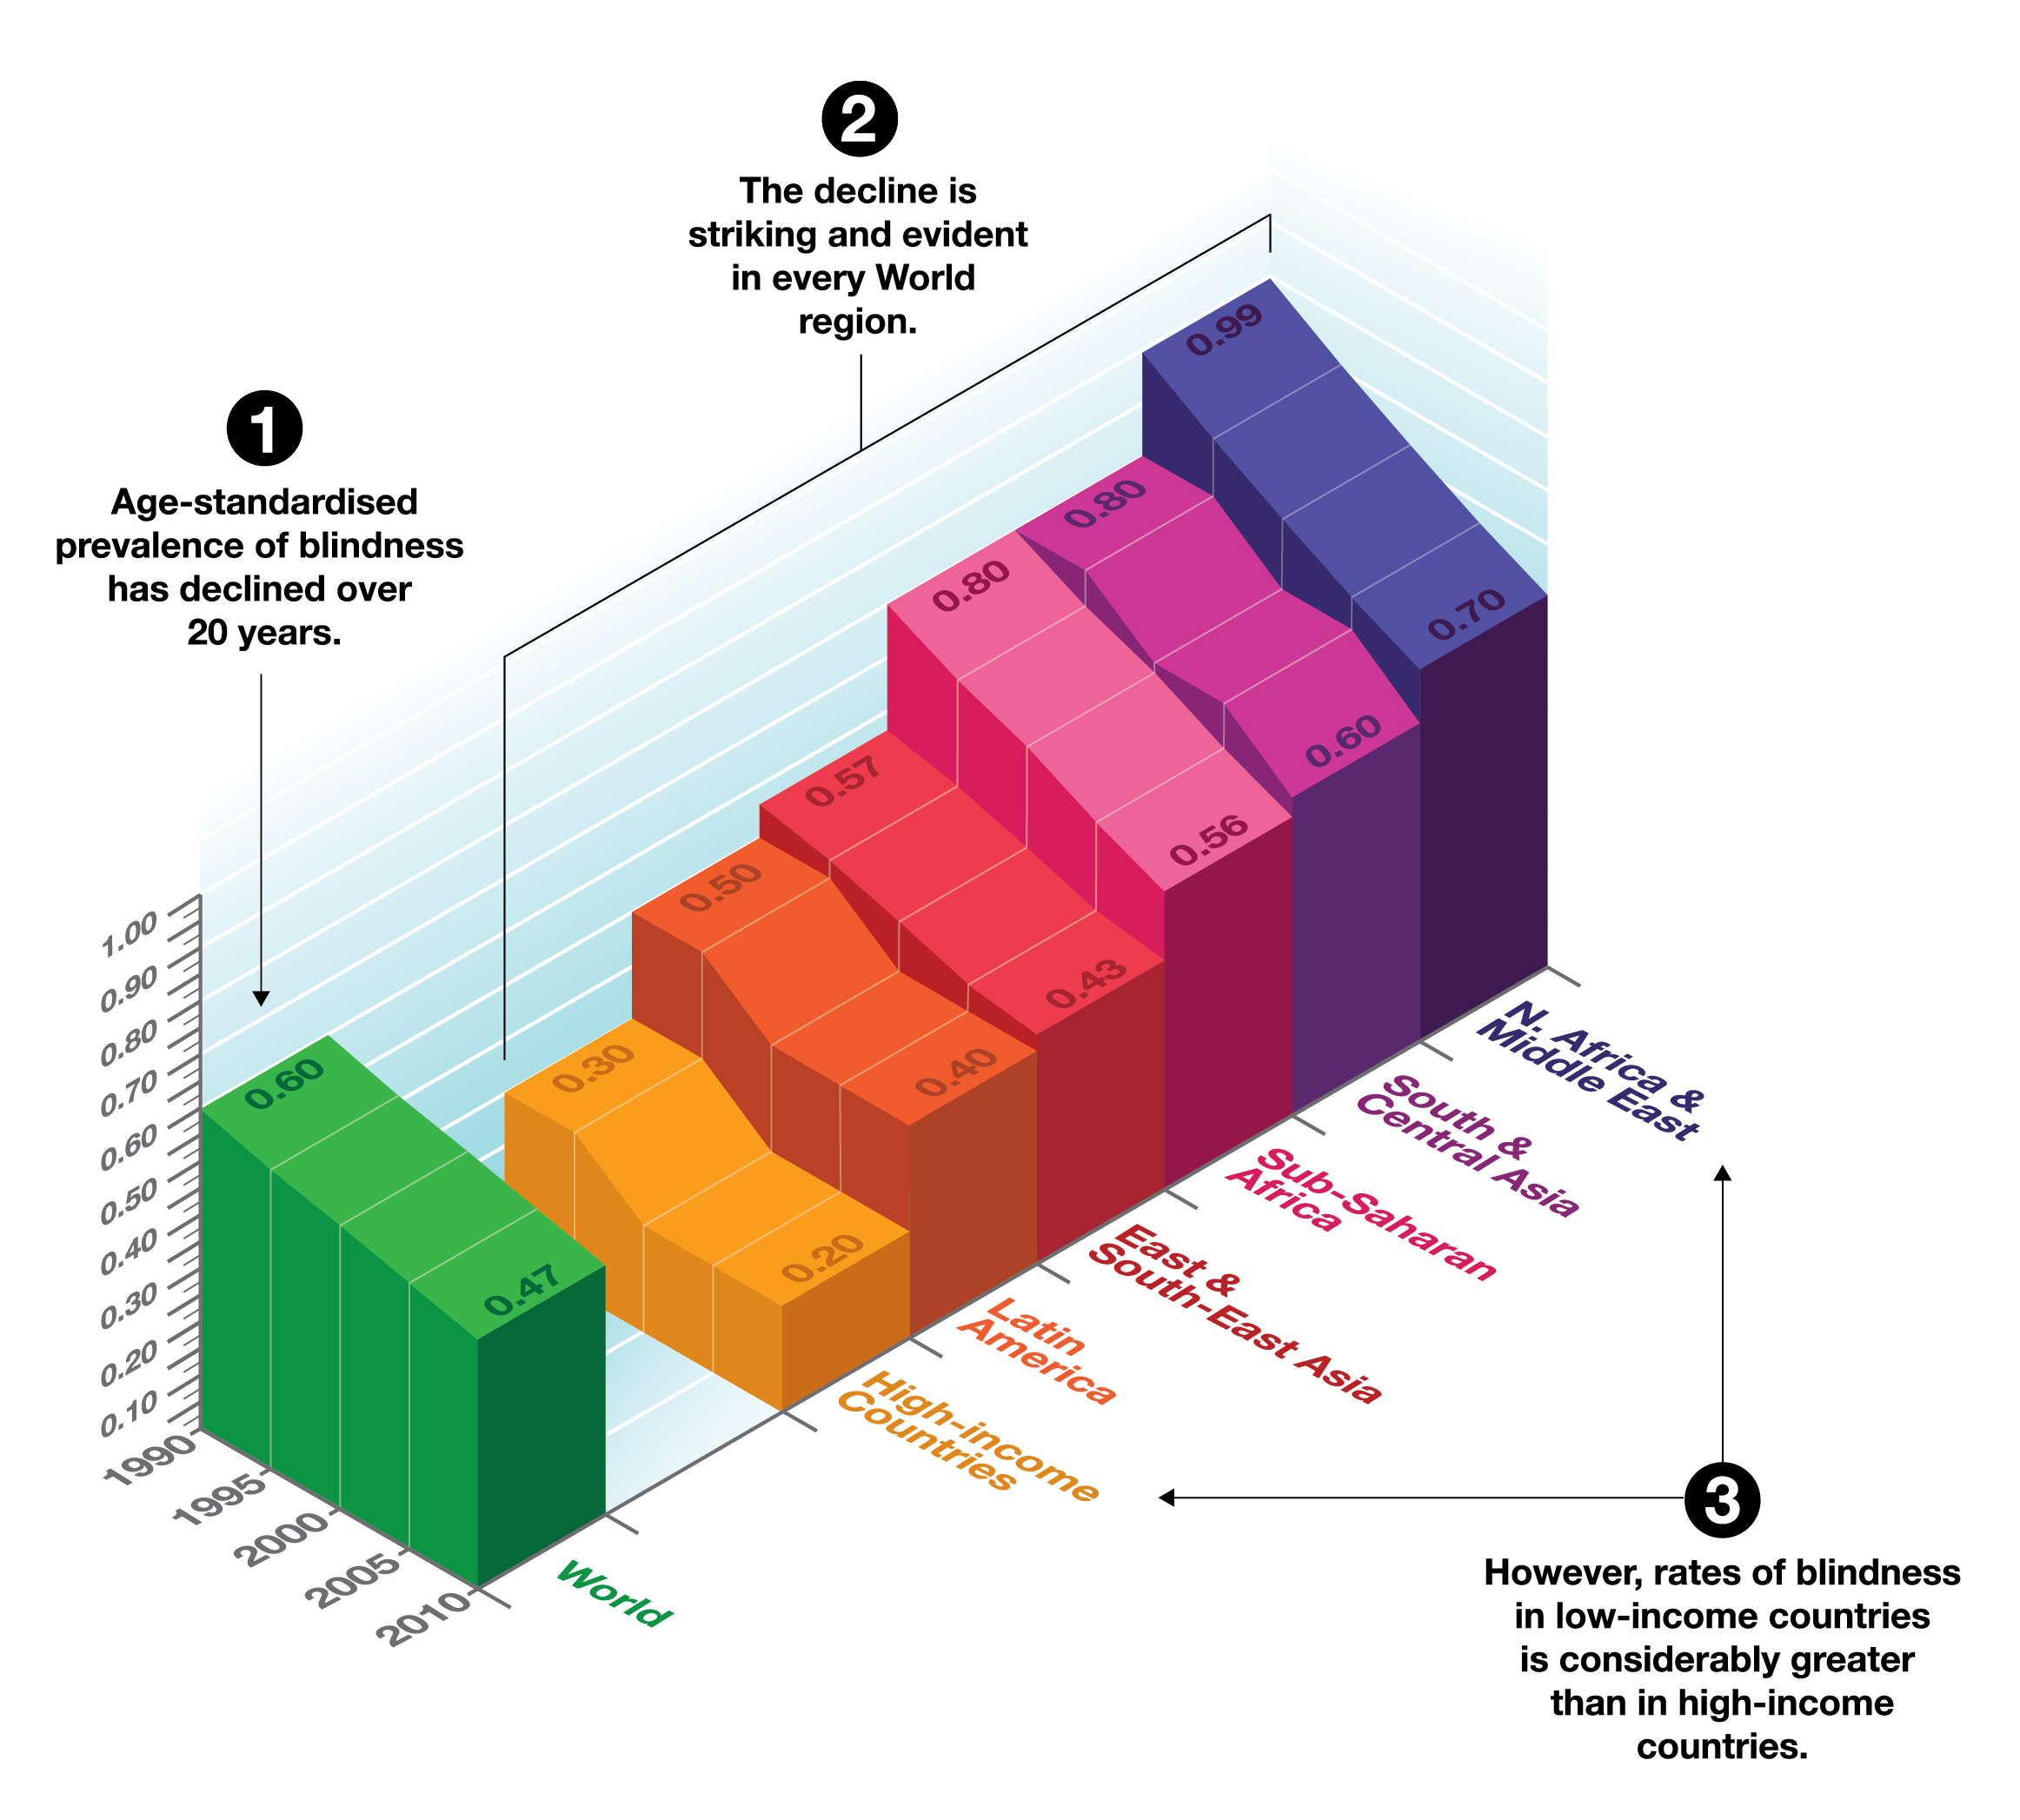

Table 4 The age-standardised prevalence rates of blindness for population aged 50 years and older over time for the world and for regions.

 | World | East & South East Asia | High Income Countries | Latin America | North Africa + Middle East | South & Central  Asia | Sub  Saharan Africa
1990 | 2.95% | 3.10% | 0.92% | 3.10% | 6.96% | 5.23% | 6.11%
1995 | 2.73% | 2.79% | 0.82% | 2.72% | 6.30% | 4.87% | 5.64%
2000 | 2.46% | 2.40% | 0.71% | 2.40% | 5.52% | 4.50% | 5.20%
2005 | 2.17% | 1.97% | 0.63% | 2.10% | 4.67% | 3.97% | 4.73%
2010 | 1.93% | 1.70% | 0.57% | 1.86% | 3.97% | 3.46% | 4.25%

Fig 2 The change in age standardised prevalence rates of blindness for population aged 50 years and older over time for the world and for regions.
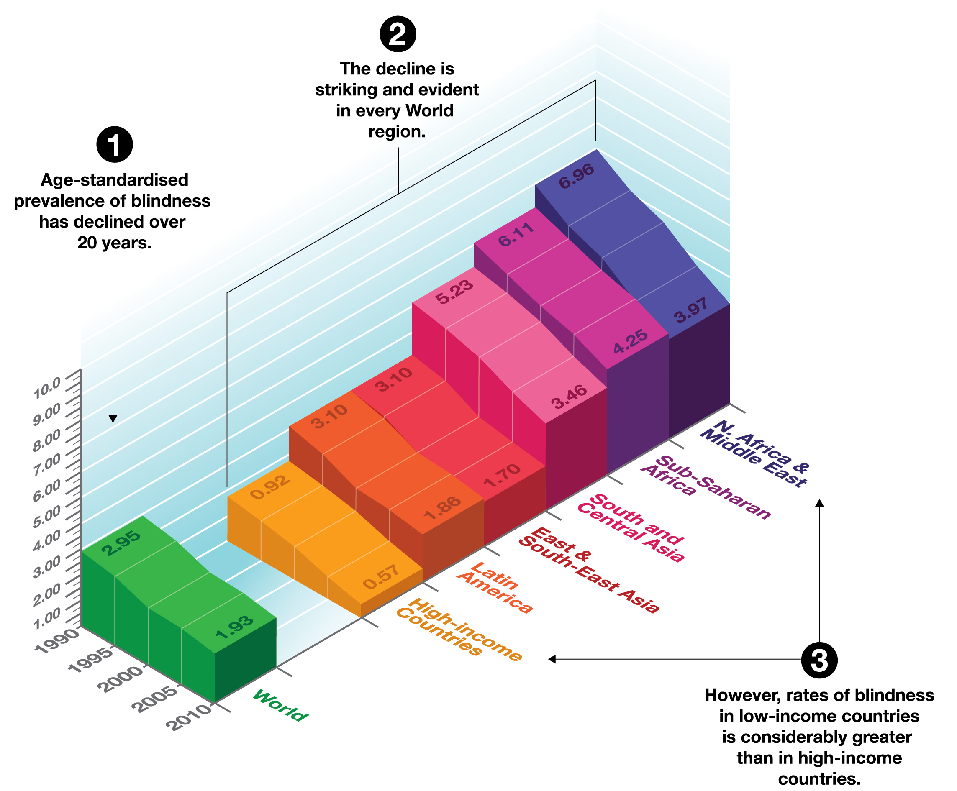

The decline in these age-standardised prevalence rates, both globally and in each region, over the past 20 years is striking and happens everywhere. This is the most powerful evidence that the fight to eliminate avoidable blindness and vision impairment is being won.
The data is also useful in highlighting the fact that the underlying rates of blindness in the low income countries is considerably greater than in high income countries.
Why have prevalence rates declined?
It is clear that the age-standardised prevalence rates have declined steadily over the past 20 years. This is obviously a fact to be celebrated but the GBD data does not set out to explain why the age standardised prevalence rates have declined. One may conjecture that it is due to a number of factors including a decline in poverty levels, improved public health measures and eye health service development.

Summary
The absolute numbers of blind persons in the world has not changed over the period 1990 to 2010 and has remained around 32 million. However with a rapidly growing and increasingly elderly global population one would have anticipated that the numbers would have increased significantly during this period.
The absolute numbers mask an impressive decline in the percentage of population that are blind – the age-standardised prevalence (for all ages) has declined in all regions and globally from 0.6% in 1990 to 0.47% in 2010.
Figure 3 summarises these changes:
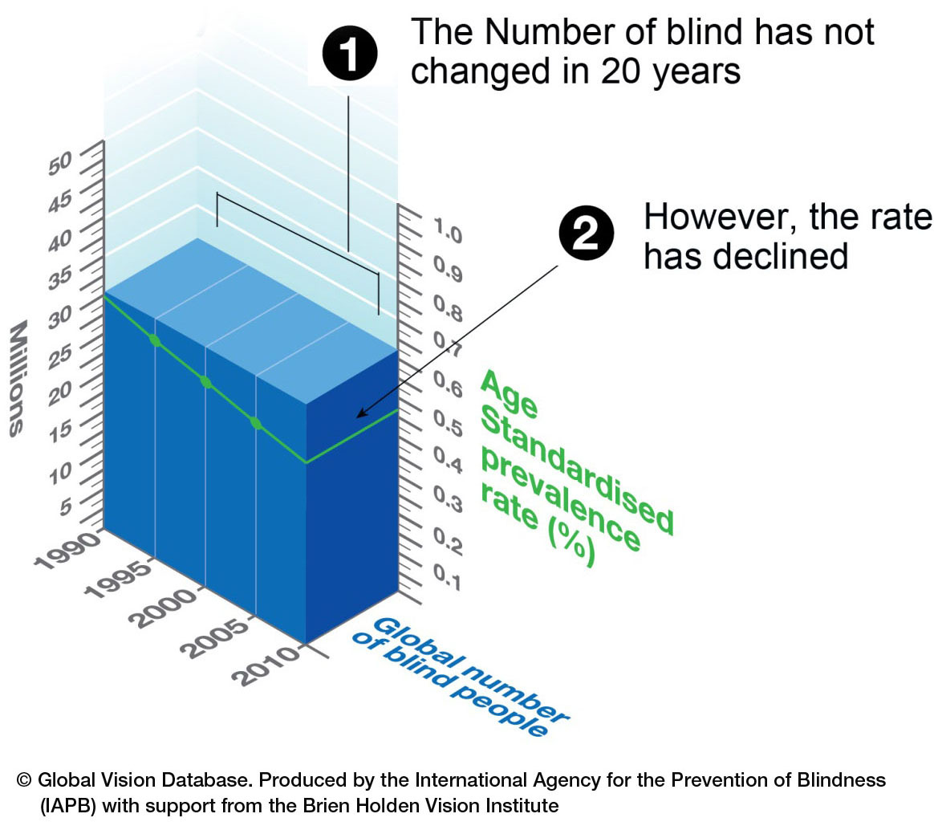
References
The data for this briefing paper is taken from papers produced by the GBD Vision Loss Group and subsequent personal communication between the authors of this briefing paper, Professor Rupert Bourne and Peter Ackland with inputs from Dr. Gretchen Stevens.
- Bourne R, Price H, Stevens G. Global Burden of Visual Impairment and Blindness. Arch Ophthalmol. 2012;130(5):645-647.
- Rupert Bourne, Holly Price, Hugh Taylor, et al. New Systematic Review Methodology for Visual Impairment and Blindness for the 2010 Global Burden of Disease Study. Ophth Epidemiol 2013;20(1):33-9.
- Rupert R A Bourne, Gretchen A Stevens D.Sc.^{2a},* Richard A White PhD³, Jennifer L Smith MSc ⁴, Seth R Flaxman BA⁵, Holly Price PhD¹, Jost B. Jonas MD⁶, Jill Keeffe PhD⁷,** Janet Leasher OD^{8**}, Kovin Naidoo PhD^{9**}, Konrad Pesudovs PhD^{10**}, Serge Resnikoff PhD^{11**}, Hugh R Taylor MD. Causes of Global Vision Loss: 1990-2010. The Lancet Global Health 2013. E-Published 11 November 2013.
- Gretchen A Stevens, Richard A White, Seth R Flaxman, Holly Price, Jost B. Jonas, Jill Keeffe, Janet Leasher, Kovin Naidoo, Konrad Pesudovs, Serge Resnikoff, Hugh Taylor, Rupert R A Bourne, on behalf of the Vision Loss Expert Group. Global Prevalence of Vision Impairment and Blindness: Magnitude and Temporal Trends, 1990-2010. Ophthalmology. 2013 Dec;120(12):2377-84.
- A series of 7 papers, one for each region of the World, are being published in Spring 2014 by the British Journal of Ophthalmology.

