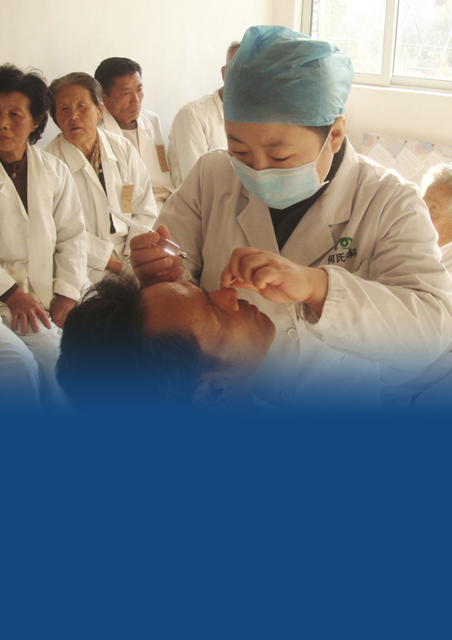

IAPB Human Resource for Eye Health Working Group
Allied Ophthalmic Personnel
Training the Trainers
Curriculum
International Agency for the Prevention of Blindness
October 2016

Cover photo: He Universiy Eye Hospital (from the #EyeCareForAll Photo Competition)

Preamble: Lack of well-trained eye care team members is one of the most significant barriers to delivering and improving eye care globally. In particular, competent Allied Ophthalmic Personnel (AOP) are needed to produce efficient low-cost eye care teams and competent trainers are needed to produce competent AOP. The ultimate goal of this curriculum is to provide resources necessary to educate trainers of AOP to be effective educators. In turn, this will assure AOP develop the knowledge and skills essential to the eye care team

Below is a list of competencies thought to be important for trainers of AOP. Ultimately each of these items will represent a module containing goals, objectives, teaching materials and assessment methods. This list, in part, originated in the International Council of Ophthalmology Ophthalmic Educators Curriculum.

I. Teaching Principles (This section includes concepts and principles important for effective teaching and learning. These principles should be adopted by teachers to increase student learning and competency achievement.)

A. Adult Learning Principles (There exist a variety of principles thought important to effective adult learning. These include theories of Knowles, Schon and Ericsson.)
B. The Roles and Competencies of a ‘Good’ Teacher (This section considers qualities and specific techniques employed by effective teachers.)
C. Teaching & Learning Styles (Teachers and Learners do so in different ways. This section covers a variety of teaching and learning style theories in addition as to why it is important to consider in your teaching.)
D. Outcome- and Competency-based Education (Competency can be defined as the ability to perform a task well. New paradigms in education suggest competency based education is the best approach in the medical field. Outcomes of tasks performed are a measure of competency.) Link to IJCAHPO/ICO AOP Curriculum for examples.
E. Giving Useful and Effective Feedback. (Information describing students’/faculty’s performance in a given activity that is intended to guide their future performance in that same or related activity. Important principles: timely, frequent, expected; based on first-hand data; descriptive; constructive; specific; nonjudgmental; balanced.

II. Teaching Methods (Principles and methods used for instruction)

- Teaching concepts, facts, principles, processes, procedures (These different content types need different teaching methods to ensure learning)
- Problem-based learning (Students learn about a subject matter through the experience of solving an open-ended problem).
- Large Group Teaching (Traditional lecturing and its many variations and approaches)
  - PowerPoint Presentations (principles of creating good PowerPoint slides and presentations).
  - Combining Media Elements (appropriate integration of images, videos and any other media used in lecture).
  - Lecture Structure (Appropriate structure of the lecture with the key elements of introduction, body and conclusion and their sub-components)
  - Flipped classroom (A technique where the medical knowledge portion of a lecture is recorded and viewed by participants before the face-to-face teaching. The teacher can then use class time to emphasize higher cognitive thinking).
D. Teaching Non-Technical Competencies (Non-technical or “soft” competencies are those beyond medical knowledge and technical/surgical skills. They need special methods and tools for teaching and assessing)
Communication and Interpersonal Skills, Ethics, Professionalism
E. Simulation (Scenarios or case presentations that reproduce real life situations for the purpose of teaching)
F. Mentoring (A mentor is a counselor or teacher who motivates and assists a junior colleague in attaining success. The mentor supplies information, gives advice, facilitates professional networking, and offers critical support to the mentee)
G. Small Group Teaching (Small-group sessions may complement large-group teaching (i.e. lectures) by further exploring key concepts in lectures and readings, applicability, discussions, understanding of difficult material, etc.)
Workshop Development
H. Independent learning (Students work on their own to meet their own learning needs. They have control over their own learning (also “self-managed/directed/regulated”). May precede or follow a lecture, small-group session, or clinical session; before a formal examination; and during e-learning)

III. Technology Assisted Teaching and Learning (Tools and instructional design strategies for developing electronic mediated teaching interventions)

- Running Successful Webinars (Theory and practice on running webinars)
- Synchronous vs. Asynchronous Learning (Comparison of online activities when students and teachers are on line at the same time and when each gets online at any time)
- ICO Web Resources (Describes the ICO website for educators)
- Non-ICO web resources for teaching and learning
- Developing performance support aids (Describes how to develop resources that will support work performance after training)
- Mobile learning (Describes uses of portable devices for teaching and learning)
- The Course Syllabus (Describes components of a course)

IV. Training Design (stepwise approach to creating a course or program)

- Determine Competencies
1. Problem Identification and General Needs Assessment (of a health care need or other problem. It requires an analysis of the current approach of patients, practitioners, medical education system, and society to addressing the identified need. It is followed by identification of an ideal approach of how the need should be addressed. This analysis results in the competencies deemed necessary for the AOP in question.
B. Goals & Objectives (Goals are broad and general; objectives are specific and measurable. Objectives may include cognitive (knowledge), affective (attitudinal), or psychomotor (skill and behavioral); also process objectives (i.e. conduct of the curriculum), or health, health care, or patient outcome objectives. Good goals and objectives facilitate teaching plan development and point the learner to the important aspects of the teaching. Principles of creating good goals and objectives are described.)
C. Assessment Principles & Methods
1. Importance and Role of Assessment (To support teaching and learning by fostering learning; to provide information about students, teachers, and schools; to act as a selection and certification device; to predict future success; to ensure the safety of the public; to set standards and monitor the quality of education)
2. Assessment Principles (Validity (does the assessment measure what you want it to measure?. Reliability (is the assessment completed the same by different assessors viewing the same situation or by the same assessor viewing a situation multiple times?). Feasibility (is the assessment practical in terms of frequency, duration?)
3. Assessment Methods
- Formative versus Summative (formative feedback is aimed at improving behavior whereas summative is a measure of competence.)
- Work place based assessment (assessment done on-the-job observing skill of an individual.)
- Rubrics (A rubric is an assessment tool with dimensions (e.g. steps of a procedure), levels (e.g. novice, beginner, advanced beginner, competent), and descriptors of the behavior one expects to observe for each dimension and level
- 360-degree evaluation (Usually a survey of the various people (e.g. patients, peers, staff) who interact with the individual being assessed. Survey questions are tailored to the group doing the assessing.)
- Observed clinical and procedural/checklists (Checklists are usually simply a list of steps of a procedure or task which are simply “done” or “not done.”)
- Multiple-choice questions (principles of writing good MCQs)
- Self-assessment (verbal or written assessment of one’s own abilities, often part of a 360 evaluation.)
4. Faculty Assessment (Consider the goal of the evaluation, available data sources (e.g. participants, peers, students, etc.), and methods of evaluation (e.g. questionnaires, focus groups, objective tests, observations).
5. Program Assessment (Kirkpatrick’s levels of evaluation - reaction, learning, behavior, results).
D. Learning Activities (to include instruction on how to select the best learning format for the competency to be taught.)

VI. Program Management
- Remediation of problematic students (Should include definition of deficiencies, provision of resources for improvement, communication of clear goals for acceptable performance, and reevaluation of performance against these goals)
- How to Achieve Faculty Cooperation
- Governing Principles and rationale regarding enrollment, performance, progression.

VII. Team Training Concepts
- What is Team Training? (Interprofessional Education) (Occasions when two or more professions learn from, with, and about each other to improve collaboration and the quality of care).
- Principles and benefits (Principles: Understand and respect the roles and expertise of health and social care professionals in the context of working and learning as a multi-professional team. Benefits: an effective interdisciplinary team contributes to the delivery of safe and high-quality care in the context of a changing international health and illness profile, with an increase in chronic and complex disease as the population ages, the patient safety agenda, and the importance of self promotion).
- Models of Effective Team Training (Effective team training models (e.g. LV Prasad pyramid) and essential principles of task sharing, redistribution and standardization.)

VIII. Certification/Accreditation* (Describes the definition and process for accreditation and certification).
- Individual Certification
Methods, models and rationale
B. Program Accreditation
Methods, models and benefits

