HEAD START Summary
Trachomatous trichiasis is an eye condition caused by repeated ocular infections with the bacterimum chlamydia trachomatis. The disease is common in rural areas of developing countries with limited access to water and hygiene practices, with flies carrying the infection from one child’s face to another. In children, infection presents as conjunctivitis. However, years of repeated infection cause the eyelid to scar and turn inward such that the eyelashes rub against the eye, a condition called trichiasis. If not corrected, the continual scratching of the eyelashes on the eye can lead to irreversible blindness. Trichiasis is 2-4 times more common in women than men. It is corrected through surgery that involves making an incision along the length of the eyelid and rotating the eyelashes back to their original position. Over 2 million individuals currently need trichiasis surgery. Most surgery is performed by health workers with limited nursing training and a short course (~1 month) on how to perform the procedure.
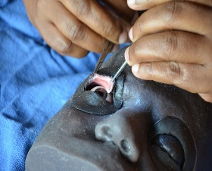
Prior to funding through Seeing is Believing, most surgery trainees went straight from classroom training to practice on live patients. Through generous support from IAPB and Seeing is Believing, our team was able to develop and evaluate HEAD START, a surgical simulator that allows trainees to practice the key steps of surgery in a safe setting before performing surgery on live patients.

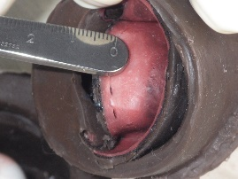
HEAD START has many key benefits. It allows the trainer to demonstrate each step of the surgery one at a time, with the trainee performing that step on the other eyelid immediately after the trainer. Additionally, it allows targeted practice on a specific step if the trainer/trainee determine more practice is needed in one area, such as suturing. Finally, unlike live surgery, the eyelid can be removed and examined to assess the straightness of the incision, and the spacing, alignment and the tightness of the sutures. All of these steps are critical for ensuring good surgical outcomes.
Our Seeing is Believing project demonstrated that individuals who participated in a single 3 hour HEAD START training session increased the speed of their first surgeries by 30%, and more importantly required 50% fewer interventions by the trainers. Further work through this funding has shown that trainees believe that weekly practice with HEAD START and monthly calls with a trainer to review their results is beneficial. Finally, within one surgical program that uses HEAD START, the frequency of poor eyelid contours after surgery is substantially lower in patients who are operated by someone who has received HEAD START training.
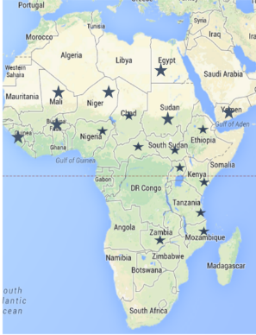
The World Health Organization has designated surgical simulation training as an essential part of both new and refresher trichiasis surgery training. HEAD START is the only surgical simulator available for trichiasis surgery practice. HEAD START training now takes place in all African countries designated as trachoma-endemic, as shown in the map.

