Accessible documents

Why create accessible documents?
To ensure everyone can read, listen and understand all the content in them. Types of impairment to consider:
- Visual – low vision, blindness, colour blindness
- Hearing
- Physical/motor
- Cognitive?

How will student/funder/practitioner access your document?
- Printed version
- Download from web e.g. the day before class to set up on their own

Examples of assistive devices for computer access
- Input devices: Modified keyboards, pointers, speech to text software
- Output devices: Text to speech software, magnifiers, screen readers, braille

Document types we use
- Common - Word; Excel; PPT, web pages……. which can all be turned into PDFs
- Less common – Video, Audio

Sally’s top 6 tips
- Structure your documents using text styles to help screen readers tab through your document (use “heading 1” for titles and “heading 2” etc for subtitles and “normal text” for main content)
- Ensure text is readable (12pt Arial and Verdana are good – I think Calibri is ok too, keep high contrast between foreground and background, align text left, not too much bold text)
- Keep tables simple. Screen readers read tables from top left to right row by row.
- Provide text versions of audio & video files
- Provide descriptions of images (add “alt” text to images). The picture below has had an appropriate alt tag attached (Select image > Go to top format tab and select size > Alt tag)
- Office 10 has an “Accessibility Checker”

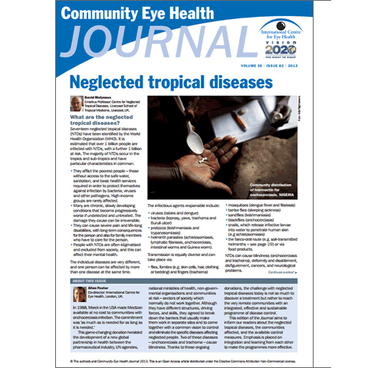

Cheatsheets and guidelines
Microsoft Office cheatsheets are good:
- Creating accessible Word documents
- Creating accessible Excel workbooks
- Creating accessible PowerPoint presentations
- Creating accessible PDFs (from World, Excel or PPT)
These accessibility Cheatsheets from the National Center for Disability and Education are also straightforward and practical. Detailed RNIB guidelines for printed materials, PDFs, Excel, Powerpoint, Word documents and web pages amongst others

YouTube examples of assistive technology for low vision and blindness
- JAWS screen reader reading a Microsoft Word document and tabbing through a document at high speed
- Introduction to ZoomText and Screen Magnifiers and Professor Megan Conway demonstrates ZoomText

