


MID-TERM REVIEW FOR CHRISTIAN BLIND MISSION´S PROJECT ENTITLED “SEEING IS BELIEVING”.

INDEPENDENT EVALUATION REPORT

By

Centre for Development, Research and Evaluation International Africa

Pindai M. Sithole (PhD)
(Team Leader, Social Research and Evaluation Expert)

Arnold M Chapanduka
(Co-Consultant, Research Assistant)

May - June 2017 Harare, Zimbabwe

29 August 2017

Table of Contents
LIST OF TABLES ii
LIST OF FIGURES iii
ABBREVIATIONS AND ACRONYMS iv
ACKNOWLEDGEMENTS v
EXECUTIVE SUMMARY vi
Objective 1: Increase the quantity and improve the quality of eye care services for adults and children over three years. vii
Objective 2: Increase the capacity of the eye-health workforce at primary, secondary and tertiary levels. vii
Objective 3: Improve the infrastructure for eye-care delivery at tertiary (Sekuru Kaguvi Hospital) and secondary level (Norton and Sakubva Eye Hospitals) vii
Objective 4: Ensure all eye-care services are inclusive. vii
SECTION ONE 1
1 INTRODUCTION 1
1.1 Introduction 1
1.2 Contextual analysis 1
1.3 Programme Goal and Rationale 2
1.4 Programme Objectives 2
1.5 SIB Purpose and Evaluation Objectives 2
SECTION TWO 3
2 METHODOLOGY 3
2.1 Data collection strategy 3
2.2 Data sources 3
2.3 Data Analysis 5
2.4 Sampling 5
2.5 Validation process employed 5
2.6 Limitations of the Evaluation 5
SECTION THREE 7
3 FINDINGS 7
3.1 Introduction 7
3.2 Project relevance and strategic fit 7
3.2.1 Project relevance at national level 7
3.2.2 Project relevance at community level 8
3.3 Regional relevance 9
3.4 Global relevance 9
3.5 Assessment of project design and Implementation. 10
3.5.1 Project design and implementation 10
3.5.2 Project community sensitization 11
3.5.3 Community Feedback mechanism and reporting 12
3.5.4 VHWs work and challenges in the project 12
3.5.5 Project Monitoring, Evaluation and Learning (MEAL) system 13
3.6 Assessment of project objectives 13
3.6.1 Objective 1: Increase the quantity and improve the quality of eye care services for adults and children over three years. 14
3.6.2 Objective 2: Increase the capacity of the eye-health workforce at primary, secondary and tertiary levels. 17
3.6.3 Objective 3: Improve the infrastructure for eye-care delivery at tertiary (Sekuru Kaguvi Hospital) and secondary level (Norton and Sakubva Eye Hospitals) 19
3.6.4 Objective 4: Ensure all eye-care services are inclusive 23
3.7 SiB Project Efficiency 24
3.7.1 Eye camps 24
3.7.2 Operations at base stations 25
3.8 Overall project impact 26
3.9 Project Sustainability 28
3.9.1 Project Sustainabilityat institutional level 28
3.9.2 Project Sustainability at Community level 28
3.9.3 Project Sustainability at Individual level 29
SECTION FOUR 30
4 CONCLUSION AND RECOMMENDATIONS 30
4.1 Conclusion 30
4.2 Overall Programme Recommendations. 30

LIST OF TABLES
Table 1: Project Achievement by objective vi
Table 2: Number of Days Allocated per each Province 2
Table 3: Summary of data collection tools used 3
Table 4: Number of people interviewed by district 3
Table 5: Sampling framework 4
Table 6: Top ten (10) out-patient general new diseases and conditions by all age groups (excluding STIs), 2014 6
Table 7: A comparison between ZNEHs KRAs and SiB project´s approach to respond 7
Table 8: SiB Project targets and actuals 13
Table 9: Comments on Quality of Service before and after Surgery 15
Table 10: Project impact to date as mentioned by project beneficiaries 15
Table 11: Trainings provided by the Sib project 16
Table 12: Ministry of Health Personnel Trained under the project 17
Table 13: Present professional capacity needs relating to eye care 18
Table 14: A comparison of SiB cataract extraction costs versus market prices 22
Table 15: A comparison of SiB Spectacle costs versus market prices 23
Table 16: Calculation of cost per patient for eye camps 24
Table 17: Calculations for SiB Base Station Operations 25
Table 18: Project impact on communities 27

LIST OF FIGURES
Figure 1: GoZ budget allocation to MoHCC 8
Figure 2 Trends in Health & Child Care Allocations (2010 -16) 8
Figure 3: SiB project design and implementation model 9
Figure 4: Project implementation flow chart. 10
Figure 5 : Source of eye Services information. 11
Figure 6: A comparison of the number of cataract extractions conducted by eye units. 14
Figure 7 Adult cataract extractions Jan-May for Sakubva and Norton. 14
Figure 8: Renovations at SKH Paediatric Unit. 18
Figure 9: Renovations done under the project (SKH) 19
Figure 10: Some of the equipment purchased under the project 20
Figure 11 : Trend analysis of the surgeries conducted at SKH. 21
Figure 12: An example of IEC materials produced and distributed by the project. 21
Figure 13: Challenges hindering the work of VHWs 28
Figure 14: Illustration of the current and proposed SIB upgraded system. 29

ABBREVIATIONS AND ACRONYMS

ARMD | Age related macular degeneration
CBM | Christian Blind Mission
CSR | Cataract Surgical Rate.
FGDs | Focus Group Discussions
GoZ | Government of Zimbabwe
HIV | Human Immune Virus
KII | Key Informant Interviews
KRA | Key Result Area
MoHCC | Ministry of Health and Child Care
NEH | Sakubva Norton Eye Hospital
OPN | Ophthalmic Nurses
PHC | Primary Health Care
PMS | Patients Management System
SCB | Standard Chartered Bank
SDGs | Sustainable Development Goals
SEH | Sakubva Eye Hospital
SiB | Seeing is Believing
SKH | Sekuru Kaguvi Hospital
TOT | Training of Trainers
VHWs | Village Health Workers
WHO | World Health Organisation
ZCfB | Zimbabwe Council for the Blind.
ZNEHS | Zimbabwe National Eye Health Strategy

ACKNOWLEDGEMENTS
Our special gratitude goes to CBM management and staff under the leadership of Deborah Tigere for their valuable support and guidance throughout this mid-term evaluation of the Seeing is Believing Project. We also express our sincere gratitude to the following people who facilitated appointments and accompanied the evaluation team during fieldwork data collection process (logistical and technical support): Rebecca Nevanji (Norton Eye Clinic), Nohlanhla Ngwabi (Sekuru Kaguvi Clinic), Mr Brian Deka, (Sakubva Hospital), Sister Muwi (Nyanga Hospital) and Mr Chiwanza (Hauna Hospital).

Special thank you to Dr Ute Dibb, Dr Patel, and Dr Macheka for their cooperation and willingness to be available for key informant interviews and for the valuable information they provided into the evaluation.

We also sincerely extend our gratitude to the leadership, management and staff of the Zimbabwe Council of the Blind, Standard Chartered Bank Zimbabwe and the Ministry of Health and Child Care for their policy input and analysis of how the SiB Project fits into the global and national efforts to respond to eye care needs among the citizens.

Last but not least, this midterm evaluation would not be possible without the valuable information volunteered by the various community members who benefitted from the project in Mashonaland West Province, Manicaland Province and Harare Metropolitan Province. Thus, we appreciate the time they put; without which the evaluation would not have been successful.

EXECUTIVE SUMMARY

The Seeing is Believing project (SiB) was implemented on the 1st of October 2014 and is expected to end on the 30th September 2017 and it was implemented in three provinces namely Mashonaland West, Manicaland and Harare Metropolitan. The project has the following six major components: 1) Renovations & Infrastructure development; 2) Supply of medical equipment and consumables; 3) Subsidised cataracts (adults & Paediatric); 4) Staff Trainings (OPNs, PHC nurses, VHWs and instruments technicians); 5) Community sensitisation meetings on eye care and screening of cataract patients; and 6) Supply of subsidised spectacles for Adults and children.

The methodology applied in this mid-term evaluation was participatory in nature which comprised mixed methodology (qualitative and quantitative) approaches. A combination of detailed interviews, focus group discussions, observation checklists and content analysis were used to collect the required data from carefully sampled sets of project beneficiaries who received eye health care services from Norton, Sakubva and Sekuru Kaguvi health facilities. Data collection tools for each of the methods were developed, pilot-tested and finalized. The full scale data collection was conducted in Mhondoro, Zvimba, Makonde districts in Mashonaland West Province, Nyanga, Mutasa and Mutare districts in Manicaland Province and in Harare Metropolitan. The collected data sets were analysed using NVivo and Microsoft Excel for qualitative and quantitative data respectively. The draft report was produced and finalised after feedback from CBM and its technical and financial partners.

The evaluation findings highlighted the following:

- Relevance
The evaluation found that the project is quite relevant as it addresses real needs and problems relating to eye health care in the targeted communities of Zimbabwe. In addition, it has strategic fit in the global Vision 2020.

- Inclusivity
The project is inclusive in its design and implementation. The key aspect of inclusivity is the introduction of subsidies aimed at addressing access challenges to eye health care services by vulnerable groups in the targeted communities due to poverty. The subsidies covered cataract operations, hospitalisation, spectacles and eye medications.

- Efficiency and Effectiveness
The SiB project is largely efficient in using material and financial resources. The evaluation found that eye camps were more effective than base station service provision in terms of the number of people served. Financially, the cost per patient at the eye camps are $19.34 compared to $59.33 at base station.

- Project achievements
Table 1 shows a summary assessment of project achievement by objectives.

Table 1: Project Achievement by objective

Objective | Achievement
Objective 1: Increase the quantity and improve the quality of eye care services for adults and children over three years. | The SIB project, has done exceptionally well on this objective through the provision of state of the art equipment and consumables, renovations and training of project personnel. All the strategies contributed towards the attainment of this objective.
Objective 2: Increase the capacity of the eye-health workforce at primary, secondary and tertiary levels. | The project performed well in terms of providing training for seventeen (17) nurses, eight (8) OPNs, 936 VHWs and three (3) Instrument Technicians. This is a 100% of the planned training at output level. Considering the outcome level indicators, it was noted that the OPNs and VHWs still have capacity gaps requiring further training / refresher training so as to ensure project sustainability.
Objective 3: Improve the infrastructure for eye-care delivery at tertiary (Sekuru Kaguvi Hospital) and secondary level (Norton and Sakubva Eye Hospitals) | Significant improvement was noticed at the three facilities both in terms of refurbishment of buildings and provision of clean water to the facilities.  All the refurbished and newly constructed buildings are now fully functional.
Objective 4: Ensure all eye-care services are inclusive. | The project ensured that all eye-care services were inclusive through providing subsidies and intensifying eye care awareness in the communities as well as available services provided through the three health facilities.  This increased the number of people of all ages and sex who received eye-care and treatment.

- Sustainability
The Project is generally sustainable mainly because of the training provided to a cross section of health personnel and instrument technicians as well as the inclusion of Village Health Workers who are at grassroots level. However, the limited financial capacity of government to continue purchasing the required medical equipment and consumables would still require support from development partners. This situation is likely to reduce the level of sustainability in eye health care services in the communities evaluated. Also, the government is less likely to maintain the subsidy strategy on eye health care services.

- Recommendations
Going forward, the following recommendations may be considered:

- Patients Management System.
The Patient Management System should be upgraded and integrated with other processes from patient registration, consultation, theatre, pharmacy, discharge and reviews.

- Incentives for Ophthalmic Nurses and Village Health Workers
The SiB Project management should develop strategies for incentivising project Ophthalmic Nurses (OPNs) and Village Health Workers (VHWs) as this is likely to motivate them to give maximum support to the project implementation.

- Strategies for achieving the outstanding targets.
If the SiB project is to achieve the outstanding targets within the remaining timeframe, it should consider strengthening/scaling up eye camps. This is because eye camps are cost-effective and they serve more people including those that are economically vulnerable in the communities.

- Involvement of traditional and religious leadership
The project should involve the community gatekeepers (traditional and religious leaders) in order to address harmful practices that work against the goal of strengthening eye care health as found in the evaluation.

- Renovations at Sakubva
It is recommended that the two theatres (Maternity and Eye) at Sakubva Eye Clinic be separated by creating individual points of entry to improve privacy.

- IEC materials
The distribution of the materials should not be confined to health facilities (Hospitals & Clinics), but also to other locations in the communities such as shopping centres, community halls, churches and any other sites which are frequented by most people.

SECTION ONE

INTRODUCTION

Introduction
This section provides background information on Christian Blind Mission’s (CBM) Seeing is Believing project (SiB) which officially started on the 1st of January 2015 and is expected to end on the 31st December 2017. It was implemented in three provinces namely Mashonaland West, Manicaland and Harare Metropolitan. The project has the following six major components: 1) Renovations & Infrastructure development; 2) Supply of medical equipment and consumables; 3) Subsidised cataracts (adults & Paediatric); 4) Staff Trainings (OPNs, PHC nurses, VHWs and instruments technicians); 5) Community sensitisation meetings on eye care and screening of cataract patients; and 6) Supply of subsidised spectacles for Adults and children.

Contextual analysis
According to the World Health Organisation (WHO), more than 314 million people worldwide are estimated to be living with serious visual impairment. Out of these, 37 million (11.8%) are blind, 124 million (39.5%) have low vision with an additional 153 million (48.7%) who are visually impaired due to uncorrected refractive errors. Africa, a continent with only 10% of the world’s population, accounts for 19% of the world’s blindness. Globally, the major causes of blindness are cataracts, which accounts for 51% of blindness, uncorrected refractive errors (18%), glaucoma (8%), age related macular degeneration (ARMD) (4%), diabetic retinopathy (4%), paediatric eye conditions (4%), trachoma (3%), and onchocerciasis (0.7%). An increasing number of people in developing countries are affected by chronic eye conditions, such as diabetic retinopathy, cataract, glaucoma and ARMD and this is partially due to an ageing population, but also due to changes in lifestyles that do not support the desired personal eye care.

Moreso, WHO estimates that 1% (approximately 125 000) of the Zimbabwean population is blind (VA< 3/60), with half of these cases being attributed to causes other than cataracts. It is further estimated that over 80% of blindness is avoidable. There is growing evidence that suggests an increasing association between one’s lifestyle and diseases including preventable blindness. It is also noted that not much is being done to raise awareness among communities on the importance of personal eye care and access to medical services. WHO further reveals that of the 125 000 people who are blind in Zimbabwe, 62,500 are blind as a result of cataracts, 12 000 have corneal scars, 12 000 have glaucoma, 5 000 are blind from diabetes retinopathy and about 31 000 are blind due to refractive error (VA <6/18), trachoma and HIV related conditions. Visual impairment due to cataract is 240 000 while refractive error contributes to about 480 000 cases of blindness in the country.

As for cataracts, Zimbabwe has a backlog of 60,000 cataract surgeries (Zimbabwe 2016 Health and Child Care). The available statistics on cataract surgical rate (CSR) show that for Zimbabwe it is >569 per million population (WHO 2012) and this figure is believed to have slightly improved since then. This is far below (77.2% below) the recommended CSR of 2, 500 per million population per year as a criterion for well performing eye health programme in a country. Ministry of Health and Child Care records show that eye diseases are among the top 10 causes (see Table 6) of Zimbabweans visiting hospitals as out-patients. However, eye health service delivery in Zimbabwe is hampered by a number of challenges which include shortage of eye health personnel, inadequate or lack of eye care equipment and related medical consumables, inadequate infrastructure and inability to retain eye health specialists due to unattractive conditions of service.

In another dimension, visual loss in Zimbabwe has also been identified as both a cause and consequence of poverty and this reduces the chance to effectively achieve the Sustainable Development Goals (SDGs) in the country. Research undertaken in Kenya, Bangladesh and the Philippines also demonstrated that people with visual loss were poorer in terms of asset acquisition compared with their sighted neighbours and that they were less likely to take part in social and economic productive activities (Polack, Mathenge, Wadud et al. (2008).

Programme Goal and Rationale
Given the above development contextual situation in Zimbabwe and globally, it was logical for CBM to design the SiB Project which complements the efforts of the Government of Zimbabwe (GoZ) in eye health care service delivery as articulated in the Zimbabwe National Eye Health Strategy (ZNEHS) 2014-2018. As captured in this ZNEHS, the Government of Zimbabwe’s vision on eye care is “A Nation whose people are free from avoidable blindness, where the blind and visually impaired are able to develop their full potential”. To eliminate avoidable blindness in the country, the GoZ believes that this is possible through sustainable provision of comprehensive eye care services which are acceptable, accessible, affordable, and appropriate to all the Zimbabwean citizens.

Programme Objectives
Listed below are the SiB Project objectives which are to:
- Increase the quantity and improve the quality of eye care services for adults and children over three years;
- Increase the capacity of the eye-health personnel at primary, secondary and tertiary levels;
- Improve the infrastructure for eye care delivery at tertiary (Sekuru Kaguvi Hospital) and secondary level (Norton and Sakubva Eye Hospitals); and
- Ensure all eye-care services are inclusive.

SIB Purpose and Evaluation Objectives
The purpose of the evaluation was to assess the SiB project achievements and challenges during its implementation from 1st of October 2014 to 31 March 2017. The evaluation had the following specific objectives:
- Assess the strategic fit and relevance of the programme design;
- Establish the extent to which the programme’s five levels of results were achieved;
- Assess efficiency in implementation of the programme in terms of resource utilisation, processes and procedures;
- Determine impacts/positive changes realised;
- Assess the likelihood of the project to achieve the planned results within the remaining timeframe;
- Document emerging good practices and lessons learnt; and
- Develop operational and strategic recommendations.

SECTION TWO

METHODOLOGY

Data collection strategy
The section focuses on the strategy/methodology employed in the evaluation in order to meet the requirements as stated in the Terms of Reference provided. Table 1 shows the work plan that guided the evaluation process. Data collection was conducted in Mhondoro, Zvimba and Makonde districts in Mashonaland West Province, Nyanga, Mutasa and Mutare districts in Manicaland Province as well as in Harare Metropolitan. Six (6) days were initially allocated for data collection and eventually three (3) days were added making a total of 9 days for fieldwork. The additional three days were necessary to complete interviews with VHWs in Nyanga and Mutasa districts. Table 2 below outlines the allocation of days in each district enumerated.

Table 2: Number of Days Allocated per each Province
Name of Eye Unit | Districts | # of days | Dates
Norton eye unit | Mhondoro | 1 | 27/04/17
Norton eye unit | Zvimba and Makonde | 1 | 28/04/17
Sekuru Kaguvi | Harare | 2 | 10/05/17 & 19/05/17
Sakubva Eye Hospital | Mutare | 1 | 04/05/17
Sakubva Eye Hospital | Hauna & Nyanga | 1 | 05/05/17
Additional Days
Sakubva Eye Hospital | Nyanga | 1 | 11/07/17
Sakubva Eye Hospital | Hauna | 2 | 12/07/17 & 13/07/17
Total |  | 9
Source: Evaluation Data June 2017

Pilot-testing of the data collection tools was conducted in Mhondoro District and Harare Metropolitan resulting in the refinement of all the data collection tools (FGD guide, Interview guide and Key Informant Interview guides). The refined tools were then shared in-field with the Mashonaland West Project Coordinator and with CBM during the first debriefing meeting following data collection in Mhondoro, Zvimba and Makonde. After enumeration in Mashonaland West Province, the next data collection process was conducted in Manicaland and Harare Metropolitan provinces.

At the periodic debriefing meetings, the evaluation team presented preliminary findings to CBM management. The purpose of the debriefing meetings was to seek clarification and validation of the findings as well as to get guidance on the mobilization and logistical challenges that would have been experienced during fieldwork. The evaluation team leader conducted all the key informant interviews.

Data sources

In light of the stated objectives and the purpose of the evaluation discussed in Section One of this report, the evaluation team decided to use mutually reinforcing data collection methods which were: document analysis for contextual understanding (reports, national eye care strategies and related policies), interviews with project beneficiaries (adults and children), focus group discussions with adult beneficiaries, key informant interviews with CBM leadership and management as well as with the technical and financial partners. Table 3 on the next page outlines the data sources and the collection methods used.
Table 3: Summary of data collection tools used
Data collection tools | Data source
Interview guide | Project beneficiaries (Adults & Paediatric), OPNs, SiB coordinators, Village Health Workers, Instrument technicians.
Key Informant interview guide | CBM, ZCfB, Standard Chartered Bank, Ministry of Health, Ophthalmologist
Focus Group Discussion guide | Community project beneficiaries
Observation Checklists | Health facility
Content analysis guide | Project documents, progress reports, national strategies and policies, etc.
Source: Evaluation data June 2017.

The data collection methods are briefly discussed below:
- Document reviews: Some of the documents that were reviewed include SIB project proposal, SiB P5 Form, progress reports, MoU with partners, the National Eye Strategy and other relevant literature were made available in electronic form and some in hard copies.

- Interviews with health personnel: Interviews were also conducted with health personnel who participated in the project (Project Coordinators, OPNs, General Nurses, VHWs and Instrument Technicians) as indicated in Table 3 above.

- Focus Group discussions: Five focus group discussions (FGDs) were held with adult project beneficiaries and their household guardians separately and one with the parents/guardians of children who benefitted from the project. The main aim of FGDs was to obtain experiences and changes, if any, in personal life of the adult beneficiaries and their guardians following cataract surgeries and related services received through this project.

- Key informant interviews: The main thrust of conducting the KII´s was to gather strategic and policy information on national and global issues on eye care health. This was important to validate findings from communities enumerated.

Table 4 outlines the number of people consulted in each district and the type of data collection method used as listed earlier in section 1.4 above.
Table 4: Number of people interviewed by district
Name of Eye Unit | Districts | Beneficiary  Interviews | FGD participants | OPNs | General Nurses | VHWs | Technicians
Mashonaland West | Mhondoro | Pilot testing of tools
Mashonaland West | Zvimba and Makonde | 7 | 16 | 2 | 8 | 13 | 1
Harare Metropolitan | Harare | 5 | 8 | 5 | 0 | 0 | 0
Manicaland | Mutare, Mutasa & Nyanga | 6 | 20 | 3 | 0 | 4 | 1
Additional Days
Manicaland | Nyanga and Mutasa |  |  |  |  | 52
Total evaluation participants |  | 18 | 44 | 10 | 8 | 69 | 2
Source: Evaluation data June 2017

Data Analysis
The consultants used NVivo and Excel software applications to analyse qualitative and quantitative data respectively.

Sampling
The evaluation applied a two-stage cluster sampling methodology for project beneficiaries in order to provide an unbiased and well-represented estimation of the data/information obtained. The first stage was to compile a list of project beneficiaries in each district who benefitted between January 2015 and 31 March 2017. The Raosoft online sampling tool was then used to determine the number of respondents within each cluster followed by a systematic random sampling technique in Excel to select the cluster specific evaluation participants. The Raosoftonline calculator applies the formula: n=t² x p (1-p)/m² where
n = required sample size
t = confidence level at 95% (standard value of 1.96)
p = estimated population of respondents in the study area
m = margin of error at 5% (standard value of 0.05

Thus, two sampling techniques (Systematic Random Sampling and Purposive sampling) were used and these are summarised in Table 5 below.

Table 5: Sampling framework
Type of sampling | Method | Evaluation participants
Probability | Systematic random sampling | Selection of beneficiaries from the registers held at the health facilities to include the years covered to date
Non-probability | Purposive | Officials from CBM, Standard Chartered Bank, health Professionals Ministry of Health and Child Care and Zimbabwe Council for the Blind
Source: Evaluation data June 2017

In order to manage costs and time constraints, the evaluation team met with project beneficiaries at local clinics and hospitals during the data collection process and these were largely central to community members.

Validation process employed
Throughout the data collection process, the evaluation team validated their findings/interpretations during debriefing meetings as a team and with the CBM management.

Limitations of the Evaluation
The evaluation had no limitations per se except for a few mobilisation challenges of the evaluation participants in Mashonaland and Manicaland Provinces as follows:

- Firstly, the timing of meetings in the various places was not properly scheduled resulting in participants waiting for longer than planned although they remained committed to provide the required evaluation data.

- Secondly, in Manicaland Province, VHWs were not adequately mobilized which resulted in a repeat fieldwork in Nyanga and Mutasa specifically to interview VHWs.

SECTION THREE

FINDINGS

Introduction
This section is a presentation of the evaluation findings categorised by the key evaluation questions and the project objectives.

Project relevance and strategic fit
The relevance of the project was assessed from national, community, regional and global perspectives as briefly discussed below.

Project relevance at national level
The evaluation found that the SiB Project is very relevant and it complements well the country´s health priorities as outlined in the Health National Strategy (2016 – 2020) and National Eye Health Strategy (2014 – 2018). The Government of Zimbabwe’s eye care vision is “a Nation whose people are free from avoidable blindness, where the blind and visually impaired are able to develop their full potential” (National Eye Health Strategy 2014 – 2018). The overall national health strategic focus as articulated in the 2016 – 2020 Strategy is “Equity and Quality of Health: Leaving no one behind” and eye related problems are among the top ten out-patients’ diseases/conditions for all age groups (Table 6).

Table 6: Top ten (10) out-patient general new diseases and conditions by all age groups (excluding STIs), 2014
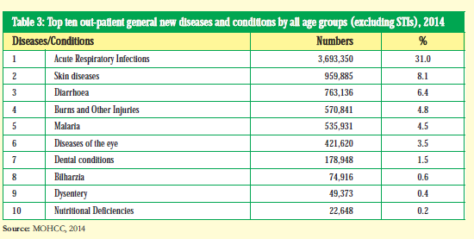
Source: MOHCC, 2014.

Table 7 below is a complementarity analysis of the relationship between SiB Project and the Zimbabwe National Eye Health Strategy (2014 – 2018) to further show how relevant the SiB Project is at the national level in Zimbabwe.

Table 7: A comparison between ZNEHs KRAs and SiB project´s approach to respond
ZNEHS -Key Result Area (KRA´s) | SIB Project´s response to addressing the (KRAs)
Prevention and Control of Eye diseases and conditions | The SiB project has responded to this through:  Community education/awareness meetings on eye care.  Community outreach meetings which are aimed at eye screenings resulting in early diagnosis and treatment.  Cataract operations/surgeries.  Provision of glasses and medication
Human Resources Development and Retention for Eye Health | The SIB project facilitated the following trainings targeting different Ministry of health staff:  Training of Trainers (TOT) targeting Provincial OPNs  Local Clinic OPNs, PHC nurses and VHWs  Training of instrument Technicians.  Refresher trainings were also facilitated as part of staff development.  The VHWs also received torches to use for primary cataract diagnosis.  These trainings have greatly improved both efficiency and effectiveness across the three (3) hospitals. OPN´s interviewed expressed confidence in the usage of the different state of the art equipment. They are now able to offer proper eye diagnosis for different eye conditions (refractive errors and Low vision and glaucoma).
Infrastructure, Equipment, Medicine and Technologies | Related to this KRA, the SiB project managed to do the following:  Renovated SKH eye unit, Sakubva Hospital eye unit and constructed new structures at Norton Eye unit.  Purchased and furnished all the three hospitals with state of the art eye equipment.  Supplied land cruiser vehicles directly and through strategic partnerships for the three hospitals.  Supplied consumables in order to facilitate operations for cataracts and other eye related challenges.
Health Management of Information System, Research and M&E | The SiB project developed and deployed a Patients management system for the three hospitals for easy management of data.
Resource Mobilization | The SiB project managed to mobilise $1,242,720 from standard chartered charted bank an amount that complements the Government of Zimbabwe´s efforts.
Programme Coordination | A decentralized approach was adopted to ensure contextual understanding of the eye problems in the communities. This was also logical to adopt this approach because both the VHWs and the clinics are located in the project target communities.
Source: SiB Evaluation Data, June 2017
Another relevance aspect of the SiB Project at national level lies in the fact that Zimbabwe’s CSR is 77.2% below recommended rate (Zimbabwe Health Strategy 2016 – 2020) which means that the project was implemented at the right time to respond to this eye care service delivery gap. Also, the project is in line with Zimbabwe constitution, Clause 76 (i) which states the need to ensure inclusive health service delivery and in part it reads: “every citizen and permanent resident of Zimbabwe has the right to have access to basic health care ...”

Project relevance at community level
The project’s deliberate bias towards rural communities in its efforts to raise awareness on eye care including provision of subsidies on surgeries makes it quite responsive to the often marginalized/vulnerable and poor members of society in accessing health services. As the evaluation found, the subsidisation was on Cataract Operations, Hospitalisation, Spectacles and eye medications as will be discussed later in this report. The subsidisation strategy resulted in an increased number of people accessing eye care services at the three (3) participating eye clinics evaluated.

Regional relevance
The SiB project contributed to the World Health Organisation´s Abuja Declaration (2001). In 2001, Africa Heads of States met and pledged to ensure that the health sector should be allocated a minimum of 15% of the total national budget. The aim was to improve people’s access and quality of health services. It should be pointed out that since then, Zimbabwe has not been able to meet this minimal health budgetary allocation threshold as shown in Figures 1 and 2 below. The trend analysis was conducted by the evaluation team and UNICEF Zimbabwe respectively.

Figure 1: GoZ budget allocation to MoHCC | 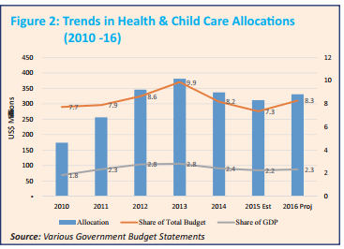  Figure 2 Trends in Health & Child Care Allocations (2010 -16)
Furthermore, the project fits in the Southern African Development Community (SADC) Protocol on Health states that “…rendering coordinated and comprehensive health services in a concerted manner is a prerequisite for the improved health status of people of the region in the 21st century and beyond…”

Global relevance
At global level, it can be inferred that the programme made positive contributions towards Vision 2020 which is a global initiative that aims to eliminate avoidable blindness by year 2020. The Vision was launched in 1999 by the World Health Organisation. In other words, the Vision 2020 is a global strategy to encourage countries to strengthen their technical capacity and channel adequate resources to effectively and efficiently address eye problems. The vision has three main strategies which are disease control, human resource development and infrastructure and appropriate technology development. The SiB components are quite relevant and strategically fit into the Vision 2020. This is because the project focuses on eye screening, raising awareness through community outreach programmes and also trainings and refresher courses for eye care professionals. Furthermore, the project is in coherent with the infrastructure development component of the Vision 2020 as evidenced by the infrastructure improvements done at SKH, Norton and Sakubva (Figures 8 and 9). In addition, the inclusive approach of the project is also consistent with the United Nations Declaration on Human Rights (UDHR) which states in part that ”Everyone has the right to a standard of living adequate for the health and well-being of himself and of his family...( UDHR Article 25).

Assessment of project design and Implementation.

Project design and implementation
The SiB project design was informed by the Zimbabwe National Eye Health Strategy (2014 -2018). All the project objectives were in direct response to the ZNEHS´s Key Result Areas. Key stakeholders within the Ministry of Health and Child Care structures and its affiliate partners contributed to the design of the project. At national level, CBM and ZCfB collaborated with the MoHCC in designing and providing technical oversight in the implementation process. Figure 3 below is a diagrammatic presentation of the stakeholders to the SiB Project design model as analyzed and snythesized in this evaluation.

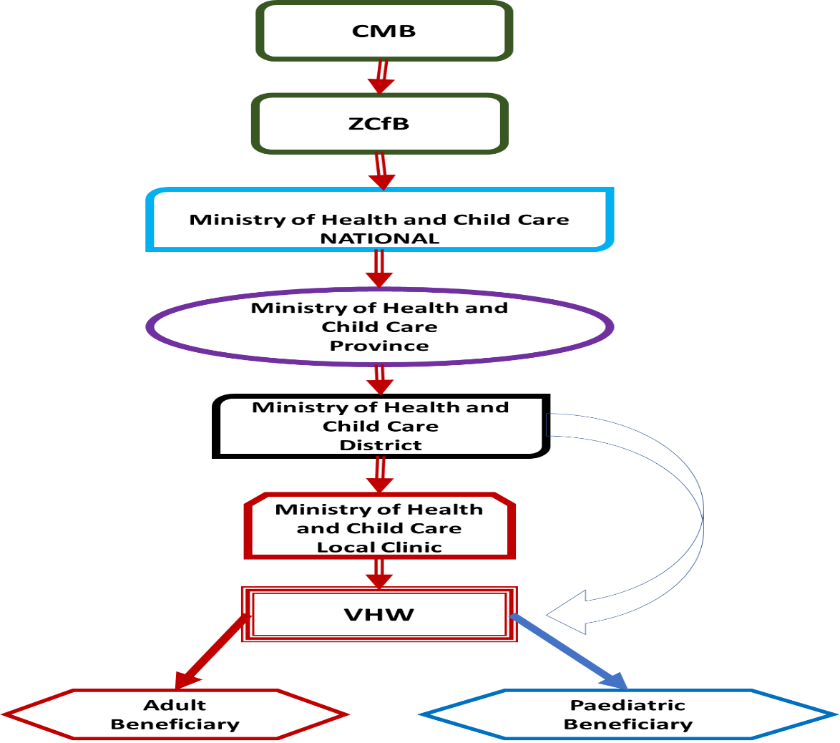
Figure 3: SiB project design and implementation model
Source: SiB Evaluation Data, June 2017

Figure 4 below is an illustration of the project implementation model in line with the design above.

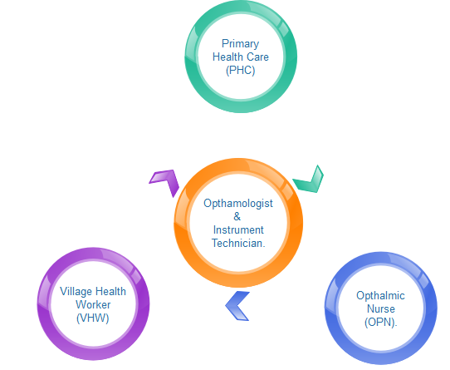
Figure 4: Project implementation flow chart.

Overall, the project design was quite appropriate as it used the existing health delivery structures in the country and leveraged on the already existing working relationship between the Zimbabwe Council for the Blind and the Ministry of Health and Child Care.

However, views obtained from project beneficiaries and stakeholders revealed that, besides working with Ministry of Health and Child Care personnel, the project has not deliberately involved the community gatekeepers (traditional and religious leaders). Issues that emerged from the communities suggest that there are some harmful beliefs held by people relating to eye problems. The participation of these leaders could have been crucial as they are gatekeepers in their respective communities/jurisdictions. Therefore, the project design and implementation should have intentionally included the community gatekeepers with the aim of addressing harmful socio-cultural beliefs and practices within the context of eye health and care.

Project community sensitization

To assess the community sensitization efforts of the project, adult beneficiaries were asked how they came to know about the eye services at the centre at which they were operated. The findings are shown in Figure 5 below.

Figure 5 : Source of eye Services information.
Source: SiB Evaluation Data, June 2017
Except for the Knew About It Already response (4%), the findings show that 96% was due to the project direct sensitization through community awareness meetings, at local clinics or simply referral by other community members.

Community Feedback mechanism and reporting
It was noted that the SiB project conducts regular customer satisfaction surveys as a strategy to get feedback from the clients and this is quite commendable as it is meant to ensure quality service delivery. These customer satisfaction surveys are comprehensive and they provide the project with detailed information on the views of its beneficiaries on the services it provides.

VHWs work and challenges in the project
The project has also selected and trained VHWs who interface with the community members in terms of provision of information on eye health and to refer eye problem cases to the local clinics. However, it was noted that the VHWs were not effectively carrying out their duties mainly because of limited knowledge and skills to deal with eye health related problems and care. In addition, 38 of 55 (70%) trained VHWs interviewed in Mashonaland West and Manicaland provinces stated that they were not quite clear of how they fit in the SiB Project referral system at the local clinics. The evaluation found that there are currently no feedback mechanisms between the VHWs and the local clinics regarding who would have undergone cataract surgeries and required post-surgery care.

Furthermore, 44 (80%) trained VHWs interviewed in Mashonaland West and Manicaland provinces reported lack of financial support / incentive in the project as one of the major challenges which limits extent of their work in the communities. In line with this finding, the evaluation found that the project had no budgetary allocations to financially support VHWs to cater for their transport, stationery, and communication requirements. This resulted in the VHWs using their own resources to participate in the project implementation especially for transport and communication. While the SiB Project assumed that VHWs are adequately remunerated and motivated through MoHCC, the prevailing situation is that they are not sufficiently and regularly remunerated. The VHWs interviewed pointed out that other community development organisations who work with them provide transport, airtime and uniforms as forms of incentive.

Project Monitoring, Evaluation and Learning (MEAL) system
Through the technical support from the Standard Chartered Bank, the SiB Project implemented a Patients Management System (PMS) specifically to improve monitoring, evaluation and learning. The same system was designed in order to assist the project in reporting to the CBM management and MoHCC. At the time of this evaluation, the system had only been deployed at Norton Eye Clinic and Sekuru Kaguvi paediatric hospital whilst Sakubva Eye Hospital is still using a manual system. At both institutions (Norton & SKH) the project coordinators stated that the system had greatly improved their work efficiency and effectiveness through easy tracking of progress, reporting as well as ease management of check-ups and follow up calls. The coordinators demonstrated their skills and competences in using the system which was quite impressive.

The following limited use and technical weakness of the system were observed at both Norton and Sekuru Kaguvi health facilities:
- The statistical reports required by the MoHCC as well as the SiB Project Coordinator are all compiled manually instead of them being generated by the system;
- Both coordinators were not up-to-date with data capturing into the system although Norton appears to be a week or two behind while Sekuru Kaguvi is several months behind with only 554 records captured out of the more than 3000 patients treated since August 2015;
- The SiB PMS’s limitation is that it is not fully online which means that real-time information cannot be obtained at the moment;
- The system is not integrated meaning that it’s not able to link patient registration with consultation room and theatre;
- Recording of patients’ details in a separate manual register and re-recording of the same patients in the consultation register unnecessarily increases work load. More so, the current system of capturing data at a later stage increases data entry errors which could be averted if it’s converted to an online system; and
- The fact that the PMS is installed on one laptop, it exposes the project to greater risks/ vulnerability particularly in the event of the laptop being either stolen or the hard-drive malfunctions.

Assessment of project objectives
This section analyses the extent to which the SiB project objectives have been achieved by the time of this evaluation.

Objective 1: Increase the quantity and improve the quality of eye care services for adults and children over three years.

The project has a total target of 7000 adult cataract operations and 390 paediatric cataract operations as indicated in the SiB P5 Excel sheet. Table 8 below indicates the project achievements to date against the planned.

Table 8: SiB Project targets and actuals
 | Target | Achievements (Cumulative to-date) |  |  |  | % Variance
 | Target | Sakubva | SKH | Norton | Total | % Variance
Cataract Surgeries (Adults) - Hospital | 7000 | 1155 |  | 1616 | 3669 | 52%
Cataract Surgeries (Adults) – Outreaches | 1500 | 563 |  | 335 | 3669 | 52%
Cataract Surgeries (Paediatric) - Hospital | 390 |  | 181 |  | 181 | 46%
Cataract Surgeries (Paediatric) - Outreaches
Other major Surgeries (Paediatric) - Hospital | 709 |  | 535 |  | 535 | 75%
Other Minor Surgeries (Paediatric)-Hospital | 176 |  | 361 |  | 361 | 205%
Totals |  | 1718 | 1077 | 1951 | 4746
Source: SiB Evaluation data, June 2017

The findings in Table 8 above reveal that, since the project inception, a total of 3,669 (37%) adult cataract surgeries have been operated. Of this total, 1,718 were conducted at Sakubva Eye clinic while 1,951 were at Norton Eye Clinic. Sekuru Kaguvi Paediatric Eye Unit has achieved 181(46%) cataract surgeries. As for major and minor surgeries, the SKH has achieved 535 (75%) and 361 (205%) respectively.

Table 8 shows that the project is far from reaching its targets especially adult and paediatric surgeries. Some of the explanations that were given by project beneficiaries include: the current cash crisis, distances to health facilities, harmful traditional beliefs that discourage some community members from seeking modern medicine eye care and just general fear of being operated. On this aspect, one FGD participant in Makonde remarked “Vanhu vanotya pavanonzwa kuti kuparwa (scratching) vanofunga kuti kuparwa kuya kuri rough”. This can be roughly translated to mean that people shun cataract operations as they think that it is a painful process of scratching eyes to remove the cataract. Furthermore, the health professionals from the three provinces indicated that they are under-staffed and the few trained personnel lack motivation thereby sometimes affect the quantity and quality of eye care service delivery.

The evaluation team went further to analyse, the trend in terms of the number of cataract extraction since 2012 to 2017 and this is presented in Figure 6 below.

Figure 6: A comparison of the number of cataract extractions conducted by eye units.
Source: SiB Evaluation Data, June 2017
As shown in Figure 6, the number of adult cataract operations is generally on an upward trend in the two eye clinics (Norton & Sakubva). Sakubva Eye Clinic consistently has less number of cataract operations compared to Norton Eye Clinic over the five year period (2013-2017). The evaluation participants from Manicaland (OPNs, VHWs and the project beneficiaries) highlighted under-staffing and general low staff motivation as major factors to low numbers of cataract operations. Figure 7 below shows a five-month trend of cataract surgeries from January to May 2017.

Figure 7 Adult cataract extractions Jan-May for Sakubva and Norton.
Source: SiB Evaluation Data, June 2017

Although the project has managed to reach 37% of its overall target, the 62 adult beneficiaries interviewed expressed appreciation and satisfaction of the project effects to their lives. In addition, guardians/caregivers also stated satisfaction on the quality of eye care services their relatives received before and after the surgeries. Table 9 below summarises the number people who expressed their level of service satisfaction across the three eye health facilities evaluated.

Table 9: Comments on Quality of Service before and after Surgery
Comments on quality of service before and after surgery | Norton | Sakubva | Sekuru Kaguvi | Total
Excellent | 7 | 3 | 2 | 12
Very Good | 4 | 1 | 2 | 6
Good | 16 | 19 | 3 | 38
Bad | 0 | 1 | 0 | 1

As illustrated in Table 9 above, the project is perceived to be of quality as well as that it is contributing to quality of people’s lives in the targeted communities. One project beneficiary from St Michaels emphasised that “the service was excellent. Before undergoing the surgery, the nurses and doctors clearly explained to me the process including what I should do after the operation”. Furthermore, adult beneficiaries during FGDs pointed out that the contributing elements to quality service in the project include renovations, equipment and supply of eye care medical consumables.

Table 11 below indicates the project impact to date as mentioned by the project beneficiaries.

Table 10: Project impact to date as mentioned by project beneficiaries
Impact | Number of adult beneficiaries who mentioned the same
Impact | Norton | Sakubva | Sekuru Kaguvi | Total
Able to read | 9 | 7 | 7 | 23
No headache pains | 3 | 1 | 1 | 4
Able to see | 16 | 4 | 1 | 21
Able to work/Can now do everything | 14 | 12 | 5 | 31
Able to drive | 2 | 1 | 0 | 3
Able to walk alone | 7 | 4 | 0 | 11
No change | 0 | 1 | 1 | 2

The following statements from some of the adult beneficiaries emphasise the impact of the SiB Project:

“Before receiving eye care treatment at Norton, I used the experience constant headaches and pain, but now I am fine. I could not afford even to read the bible or newspapers, but now I can do that very easily” (St Michael’s)

“Before my eyes were operated I could not see at all, which meant that there was nothing that I could do on my own. I literally relied on other people´s help for almost everything, from bathing, going to the toilet. I was no longer going to any church or family function including funerals. To me, I was like someone dead as I could not do anything to help myself on anything.” (Mubaira).

“Ndakakwanisa kunyora ma exams e grade 7 uye ndakukwanisawo kubetsera mhuri yangu kuita mabasa epamba sekubika, kuwacha ne kusuka.” (SKH Child)

Two of the caregivers/guardians interviewed also expressed their feelings about the project impact in concurrence with the beneficiaries cited above as follows:

“The operation was more of a prayer answered. There was nothing I could do, since I would have to spend more watching over my mother in case she needed any help or assistance. Leaving her alone would expose her to danger. She no longer bumps into objects as she used. Now she can run her life again unassisted.” (Murombedzi).

“My father is now up and about to run independently and run his life again. This now allows us time to also run our lives without having to worry about him. This has been a great sigh of relief.” (Sakubva).

As the foregoing quotations show, the project has managed to restore people’s vision, freedom, confidence, respect/dignity and livelihoods particularly agro-based. At Mubaira, one elderly woman said that she had harvested 15 bags of groundnuts and one tonne of maize during 2016/2017 farming season after regaining vision which enabled her to work in the fields once again after 15 years of blindness.

Objective 2: Increase the capacity of the eye-health workforce at primary, secondary and tertiary levels.

Under this specific objective, the project aimed at strengthening the capacity of eye health personnel (OPNs, VHWs, PHC and Instrument Technicians) as detailed in Table 11.

Table 11: Trainings provided by the Sib project
Training Content | OPNs | VHWs | PHCs | Instrument Technicians
Eye examinations / Diagnosis
Cataract Extractions
Different Eye Conditions
Elements of the Eye
Low vision
Refractions
Instrument Technicians

The above mentioned trainings contributed towards efficiency and effectiveness in delivering eye care services. Unique about this project is its bottom up approach, evident in the inclusion and training of VHWs who are responsible for community sensitisation and primary eye screening. The local health facility collaborates with VHWs for further screening, diagnosis and referral if necessary. The OPNs together with the Ophthalmologist then perform the cataract extractions. The OPNs are overall responsible for the training both primary health caregivers (PHCs) and VHWs. In order to ensure that eye care equipment is in good working condition, the Instrument Technicians were trained in their repair and maintenance.

Table 12 below summarises the number of health personnel trained in each category.

Table 12: Ministry of Health Personnel Trained under the project
Institution | OPN´s | VHW´s | PHC Nurses | Instrument Technicians
Norton eye Unit | 19 | 484 | 0 | 1
Sekuru Kaguvi | 8 |  |  | 1
Sakubva Eye Unit | 9 | 452 | 0 | 1
Total | 36 | 936 | 0 | 3
Source: SiB Evaluation Data, June 2017
The trainings that were provided to the health personnel were reported to have increased operational efficiency which in turn contributed towards an increase in the number people who accessed and benefitted from the eye care services.

The OPNs interviewed expressed confidence in their ability to execute their duties as a result of the training they received through the project. In addition, 8 of the 10 OPNs applauded the SiB project for equipping their eye health facilities with the state of the art equipment which has helped them to provide improved eye care services. The OPNs reported strengthened competencies in refraction, low vision and visual acuity diagnosis. The quotations below highlights the positive change that the project brought to eye care health personnel:

“We are now at a higher level on eye care than before. Before l could not consult eye related issues but after the trainings l can now detect a cataract, thanks to the SiB project. (St Michaels, PHC)

“I can now teach others about eye care diagnosis and refraction. I can also teach how to use different eye equipment like the refractor.” (SKH, OPN)
“Now l am now able to do the practical because then we didn’t have the instruments and it was more of theory than practice.” (SKH, OPN)

“Before 2015, this eye unit had no equipment. Most of the equipment which was here was outdated. The SIB, project brought in new equipment, which helped us to link, what we have been learning in class with the actual equipment, thereby helping us to apply what we had been learning in class.” (SKH, OPN)

While the project is well accepted and viewed as relevant by the eye care health personnel especially in terms of knowledge and skills provision, VHWs citied that they have some capacity gaps which need to addressed. This is supported by the following quotation below:

“We were only trained for 3-4 hours. The content of training was very informative but the time was short such that we have not understood the concept. Hatisati taibva.” (Nyanga)

The need for additional training was echoed by OPNs and PHCs and the majority of the VHWs interviewed as outlined in Table 13 below.

Table 13: Present professional capacity needs relating to eye care
# | Issue | OPNs  n = 10 | PHCs  N = 8 | VHWS  n = 55
 | Still need more trainings on what was taught (Refresher Training) | 4 | 3 | 42
 | Would want to be educated on other eye related issues. | 0 | 2 | 24

As can be seen in Table 13 above, most of the VHWs expressed need for further training or refresher workshops in order strengthen their knowledge and skills in providing eye health care

Objective 3: Improve the infrastructure for eye-care delivery at tertiary (Sekuru Kaguvi Hospital) and secondary level (Norton and Sakubva Eye Hospitals)

The SiB project allocated $350,936.00 for the refurbishment of the three eye health facilities. At SKH $56,781.00 was allocated for the refurbishment for paediatric OPD and at Norton, $283,007.00 was allocated for the construction of an Operating Theatre (OT) ablution block and renovations of the male and female wards. Lastly, $11,148.00 was allocated to Sakubva hospital for the refurbishment of the OT. This investment helped to increase the number of patients receiving eye treatment especially at Sakubva eye clinic where they were sharing the same theatre for maternity and eye operations.
All the proposed renovations were completed and are now fully functional. Figures 8 and 9 below are some of the selected pictures of the renovations/refurbishments that have been done at SKH by the time of this evaluation.
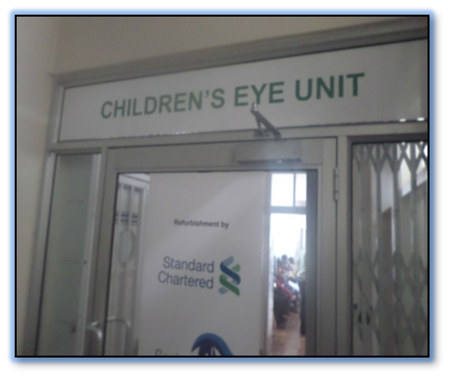
Figure 8: Renovations at SKH Paediatric Unit.

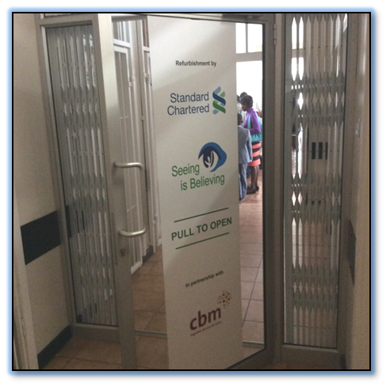
Figure 9: Renovations done under the project (SKH)

In addition, the project allocated $31,690.00 for the purchase of different state of the art surgical equipment and instruments in order to facilitate increased eye examinations and surgeries in the three health facilities. An additional $56,744.00 was allocated to SKH for the procurement of surgical equipment and instruments for the Paediatric Ophthalmic Unit. The following statement from an OPN at Sakubva reinforces how the new equipment brought through this project improved efficiency and quality in eye care service provision:

“The period prior to 2015 we used to refract using a photoreceptor. Through the SiB project we are now using an auto refractor. This has made our work much easier and less time consuming.” (Sakubva, OPN)

Figure 10 below shows some of the equipment purchased for the different eye units and have been applauded for improving both number of people accessing eye care services and improvement in the provision of eye care service delivery.

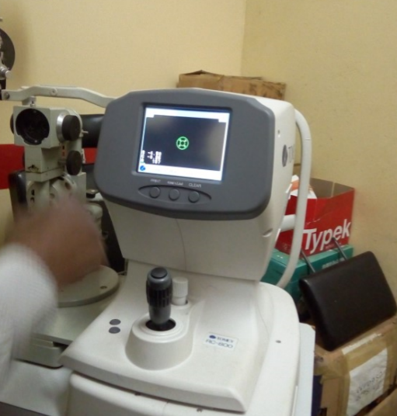 | 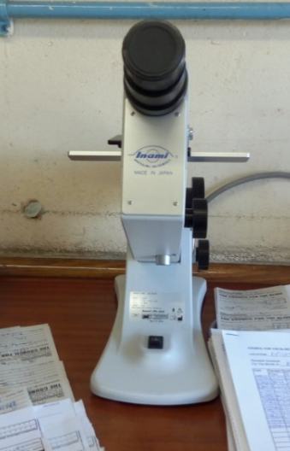
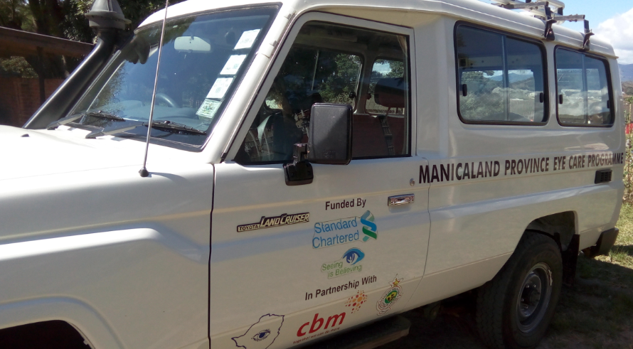  13 Seater land Cruiser, Purchased for Sakubva Eye Clinic |  | 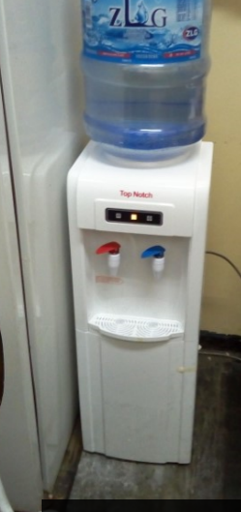  Water dispenser
Figure 10: Some of the equipment purchased under the project
Source: SiB Evaluation Data, June 2017

Besides providing the equipment, the SiB Project also supplied the required medical supplies and consumables for surgery, drugs (antibiotics and steroid combos) and cataract surgical kits. Based on the observations and testimonies from the beneficiaries, all these contributed to the quality of eye care services. Figure 11 below shows a general upward trend of children who were operated during the period 2015 up to March 2017 at SKH.

Figure 11 : Trend analysis of the surgeries conducted at SKH.

In addition to the supply of equipment and medical consumables, 13-seater Land Cruiser vehicles were donated (one each) to both Norton and Sakubva eye health facilities which are being used to transport people from various communities for cataract surgical operations. From the evaluations findings, priority of ferrying patients is given to those staying far away from the health facility. Although at Sekuru Kaguvi no vehicle was purchased through this project, there is a similar vehicle which is used to transport paediatric patients from provincial hospitals to Sekuru Kaguvi.
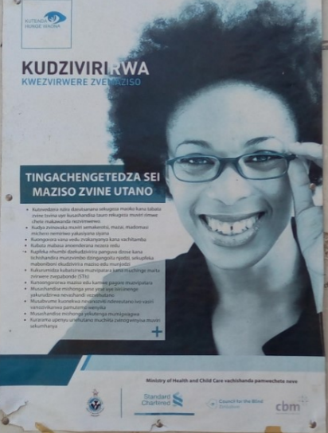
Another important aspect which is directly linked to the increase in number of people accessing eye health care services (see Figure 11) is the project’s information education and communication (IEC) materials which were visibly seen at the different health facilities, CBM offices and Standard Bank branches. The SiB project allocated $8,000.00 for the design and production of IEC materials which were printed and distributed through the Ministry of Health and Child Care structures (local clinics and hospitals).
It was observed that the current distribution channel (Provincial, District and Local Clinics) excludes that group of people that will never visit these centres due to traditional and religious beliefs and a good example is the members of the apostolic sects.
Figure 12: An example of IEC materials produced and distributed by the project.

Figure 12 is an example of the IEC materials that were designed and distributed by the project and most of these were visible at Provincial, District Hospitals and local clinics. However, such materials could not be seen anywhere else in places that are frequented by many people such as growth points, community centres and other strategic places.

The trained VHWs were provided with torches for cataract screening and pocket-size pamphlets for use at community eye health awareness meetings.

The evaluation also found that, most of the VHWs interviewed did not have training materials (Notes & Training Aids) to use when conducting community awareness meetings. For example, one VHW at Sherukuru clinic said “Tinodawo zvinoita kuti tinyatsosimbaradza madzidzisiro kuvanhu” (We need training materials to improve quality of the training we offer to people). In Manicaland, most of the VHWs had only been allocated with some pamphlets which were not ideal for community awareness. The second major challenge raised was related to identification (T shirts & hats) especially when conducting SiB business. T-Shirts and hats could act as a motivation. Related to this, one VHW said “Tibatsireiwo nema uniforms kuti tigone kugamuchirika muvanhu” Mobility has also been a major challenge; since most of the bicycles provided by other projects are currently not working and requiring some minor repairs so that they can used to service the community. Whilst providing the above requested items may not offer permanent solutions to the problems, they will in the short run motivate and incentivise the VHWs to effectively execute their mandate.

Objective 4: Ensure all eye-care services are inclusive

Cataract Surgeries
In line with the SiB project inclusive thrust, a number of strategies were adopted. Key among them is the introduction of subsidies for eye care services including cataract surgeries, hospital fees and spectacles. Table 14 below is an analysis of these subsidies versus market prices in the public sector.

Table 14: A comparison of SiB cataract extraction costs versus market prices
Description | SIB Project Cost per eye | Normal price (Public) | Variation | % of project cost as compared to the normal Gvt Hospital prices
Cataract Surgeries >65 | $95.00 | $180.00 | $85.00 | 53%
Cataract Surgeries <65 | $25.00 | $180.00 | $155.00 | 14%
Paediatric Patients | $25.00 | $180.00 | $155.00 | 14%
Source: SiB Evaluation Data, June 2017
The project has made it possible for senior citizens (over 65years) to have cataract surgeries free of charge with nominal cost of $25 for the purchase of contact lenses. Patients below the age of 65 are required to pay $25.00 for the lenses and $70 hospital fees bringing the total cost per eye to $95.00. As shown in Table 14 above, adult beneficiaries pay only 53% of the normal price of cataract surgeries whilst paediatric beneficiaries pay 14% thereby making the prices affordable and inclusive.

For the community members who cannot afford to raise the subsidized amounts mentioned above, the project also made a provision for them to receive free eye care services at SiB Project organized community eye camps. As a result of this strategy, vulnerable people have benefited from the project regardless of their financial difficulties.

At SKH, inclusivity is compromised especially for poor parents and guardians who stay far away from Harare. They find it difficult to raise money for transport to bring their children for medical treatment. In addition, they also face financial challenges for accommodation and food while their child/children receive medical treatment. At SKH, the hospital charges $15.00 per night for a parent/guardian taking care of their child at the hospital.

Spectacles
The project also provided subsidised fees on spectacles and Table 15 below presents price comparison.

Table 15: A comparison of SiB Spectacle costs versus market prices
Description | SiB Subsidised rate | Normal Price (Private) | Variation | % of project cost as compared to the normal price
Adults | $120.00 | $180.00 | $60.00 | 67%
Paediatric Patients >5 | $6.00 | $150.00 | $144.00 | 4%
Paediatric Patients <5 | $13.00 | $150.00 | $137.00 | 9%
Source: SiB Evaluation Data, June 2017
Table 15 above shows that the project has made products and services affordable to vulnerable groups. For example, adult beneficiaries pay 67% of the normal prices while paediatric beneficiaries pay 4% and 9% of the normal prices for ages greater than 5 years and less than 5 years respectively.

SiB Project Efficiency
In order to assess whether the SiB project is efficiently using its financial and material resources, two scenarios were analyzed and these are eye camps and cataract extractions at base stations using Sakubva as an example.

Eye camps
An eye camp is when eye unit personnel (Ophthalmologist and OPNs) literally camp and conduct cataract surgeries in the communities over a period of say 4 days. On average six (6) health professionals are required as highlighted in Table 14 below. On average, 150 patients can be operated on each mission depending on the quality of mobilisation and the preparedness of the team. The total cost for each camp can be estimated at $2,900.00 which brings the cost per patient to $19.34 as shown in Table 16.

Table 16: Calculation of cost per patient for eye camps
 | Transport Cost | # of Km Travelled. | Km/L | Fuel Required | Cost/Litre | Total Cost
1 | Fuel | 600 | 7.5 | 80 | 1.21 | $ 96.80
2 | Tollgates |  |  |  |  | $ 4.00
 | Total |  |  |  |  | $ 100.80
 | Allowances | Daily Rate | # of Days | # of Personnel | Total Amount
1 | Ophthalmologist | $ 70.00 | 4 | 2 | $ 560.00
2 | Scrap nurse | $ 70.00 | 4 | 2 | $ 560.00
3 | Runners | $ 70.00 | 4 | 2 | $ 560.00
4 | Assistants | $ 70.00 | 4 | 2 | $ 560.00
5 | Driver | $ 70.00 | 4 | 2 | $ 560.00
 |  | $ 350.00 |  | 10 | $ 2,800.00
 | Total Costs |  |  |  | $ 2,900.00
 | # of Patients Operated | 150
 | Cost Per client | $ 19.34
Source: SiB Evaluation Data, June 2017
Overall, the eye camps are an efficient way of using project financial and non-financial resources. The key advantages of eye camps are as follows:
- Cost effective for community members as the service is free and is within walking distance;
- Post operation care risks are minimised as there is no vehicle induced shaking/vibrations of the body since the patients just walk back home.
- Family and community support is higher since it is cheaper for members to accompany the patient without the need for neither transport nor accommodation.
- More people can be attended to at the camp than at base stations.

The only draw-back of the eye camp strategy in view of the current shortage of health personnel in the country is that base stations are not normally left with inadequate specialist eye care personnel to attend to check-up and new patients during the eye camps.

Operations at base stations

Two systems feed into the base station operations namely, walk in patients as a result of sensitisation that would have taken place and patients transported from communities. On the transportation of patients from communities, the donated project vehicle is used to ferry patients for cataract extractions at the eye clinic. In order for this process to be successful, two (2) OPNs and a Project driver are required on each mission for three days. The role of OPNs in each trip is to screen cataracts and select 10 patients based on the severity of the problem who are then transported to the eye care clinic for operation. After each operation, the same team accompanies the patients back to their homes. What this means is that each episode requires two (2) trips. Using this model/approach, it costs an average of $59.33 per patient and in order to reach 150 patients, it will cost the project an average of $8,900.00. Table 17 below illustrates how these figures have been calculated.

Table 17: Calculations for SiB Base Station Operations
 | Transport Cost | # of Km Travelled. | Km/L | Fuel Require | Cost/Litre | Total Cost
1 | Fuel (First Trip). | 600 | 7.5 | 80 | 1.21 | $ 96.80
2 | Fuel (Second Trip). |  |  |  |  | $ 4.00
3 | Tollgates (first Round) | 600 | 7.5 | 80 | 1.21 | $ 96.80
4 | Tollgates (Second Round). |  |  |  |  | $ -
 | Total |  |  |  |  | $ 197.60
 | Allowances | Daily Rate | # of Days | # of Personnel | Total Amount
1 | OPN | 54 | 3 | 2 | $ 324.00
2 | Driver | 70 | 3 | 1 | $ 210.00
 |  |  |  | 3 | $ 534.00
 | Total Costs |  |  |  | $ 534.00
 | # of Patients Operated | 9
 | Cost Per client | $ 59.33
 | Cost of reaching patients | 150 |  | $ 8,900.00
Source: SiB Evaluation Data, June 2017
The analysis provided above indicates that the base station operations are less cost-effective compared to the eye camps. This is because the cost per patient at base station is $59.33 compared to eye camps which is $19.34 and this translates to 67.4 % more expensive.

Having made the above analysis, there are some qualitative issues to be considered on these two models. Although the number of patients served at base stations is low, the infrastructure and general service environment provides quality eye care health delivery and this has been strengthened through the refurbishments and constructions of theatres at the three eye health facilities evaluated. Conversely, the eye camps do not offer the same quality facilities.

Overall project impact
The impact of the project was analysed at three levels: (a) beneficiaries; (b) health professionals; (c) and health facilities.

Beneficiaries
Those who underwent cataract extractions reported that they are experiencing a great change in their social, economic and general wellbeing as a result of their restored eye sight. The following quotations from adult beneficiaries and guardians in Mashonaland West and Manicaland Provinces emphasize this point.

During the time I was blind, I just felt like the world had just crumbled on me. Life ceased to have any meaning to the extent that I just wished I was dead. (Male, Murombedzi).

Blindness/visual impairment, takes away your freedom, rights, choices including your dignity. (Female, Mubaira)

The operation gave the child confidence because before she was hesitant to do things now she can do all things. (Guardian, SKH)

Mufaro wega wega (with hand gestures) I am now able to do everything Pfungwa dzadzikama. Ziso ndiye munhu kana usina simba panenge pasina. (Female 62 years, Makonde)

An elderly woman quoted in the last statement above expressed that before she became blind, she was free to do/go everywhere do carry on various chores at home and work in the community. During the time of her blindness, she surrendered all these rights as she had to depend on other people for everything.

The following testimony is another illustration of the impact of the project to the communities from an elderly man in Manicaland.

Box 1: Most Significant Story
This is the short story of an elderly man who became blind and because all his children were now grown up and had since moved out to start their own families, it was now only him and his wife at home. The Man indicated that due to his blindness all his chores were now being conducted by his wife. This, therefore, meant an increase in the number of the wife’s responsibilities including taking care of her husband. Due to increased chores, the wife devised a strategy to help her manage all her responsibilities, one of these strategies included tying two ropes from a central place in order to guide the husband from his usual sitting position. The first rope, would lead him to the toilet whilst the second one would lead him into the house which defined the two activities the man had to do on a daily basis. After undergoing the cataract operation at Norton, the man´s normal life has now been restored.

Health professionals
As pointed out earlier, the knowledge and the skills of the health personnel received through this project has boosted their work morale and there are also indications of improved work performance levels as evidenced by the number of beneficiaries now being attended compared to the years prior to the project implementation. Of the 52 VHWs interviewed, 37 (71.2%) said that they were now able to effectively identify cataract cases as a result of the training they received in the project. Two Instrument Technicians interviewed expressed satisfaction on the quality of training they received through this project. The table 18 below also highlights the impact of the project through four aspects that emerged from the interviews conducted with VHWs.

Table 18: Project impact on communities
Project impact on communities | Total
VHWs are now able to identify cataract cases | 37
People are now aware of how to take care of their eyes | 27
Reduced number of people with eye problems/blind | 25
Harmful beliefs, practices and perceptions about eye problems are now changing | 14
Use of unsafe traditional medicines now declining. | 11

Health facilities
As already highlighted earlier in this report, the quality of service has significantly improved due to the refurbishments made as well as the skills training of the health personnel. Generally, the facilities are now able to accommodate more people at an affordable cost. In additional, the use of the patients’ management system at Norton and SKH has increased efficiency in data management, reporting and information dissemination.

Project Sustainability
Project sustainability was assessed at three levels namely Institutional, Community and Individual. At individual and community level, the evaluators sought to assess the capacity of community members to continue accessing services at current rates considering that it may be impossible for MoHCC to maintain the subsidised rates after CBM financial support.

Project Sustainabilityat institutional level
At institutional level, the following were identified:
Firstly, all the infrastructural improvements (renovations), project vehicle, surgical equipment and instruments will continue benefiting the community sustainably since the project is not going to withdraw these as per the signed Memorandum of Agreement.
Secondly, the trainings provided to the different health personnel (OPNs, PHCs, VHWs and Instrument Technicians) will also remain within the institutions resulting in continued benefit to the communities.

However, at the national level the analysis of Ministry of Health and Child Care budget has revealed that there are no specific allocations to eye care. This means that unless this is addressed, the Government will continue to have limited capacity to strengthen and sustain eye health delivery system in the country.

Project Sustainability at Community level
The use of VHWs as primary eye healthcare facilitators, will not only contribute towards project efficiency and effectiveness at grassroots level but also contributes towards project sustainability. This is so because, they will continue offering their services even if the project comes to an end. During the evaluation, some bottlenecks for VHWs’ work were also identified, and these have the potential of reducing and sustaining the achievements to date. Figure 13 below summarises these bottlenecks.

Figure 13: Challenges hindering the work of VHWs

Top on the list of challenges hindering the work of VHWs is the knowledge or information gap which should be quickly addressed by the project through a more structured and comprehensive training. In Manicaland the following are some of the quotable quotes “Handina kuibva” (my knowledge is at a very low level). Another lady from St Augustine had this to say “Tine vanhu vakawanda vanorwara nemaziso asi isiri tsanga, asi kuti towabatsira seiko ndozvonetsa” (There are some people who have eye problems which are not necessarily cataract but we do not know how to help).

If the above-mentioned bottlenecks are addressed, the project has the potential of reaching out and benefit more people in the areas of operation.

Project Sustainability at Individual level
Given that the cataract removal is a long-term solution to the problem, the individual beneficiaries are likely to live the rest of their lives without challenges of visual impairments. Viewed from this paradigm, the project has provided a sustainable solution to the individual. Those individuals who received correctional treatment through provision of subsidised spectacles are likely to require replacements should their eye lenses weaken further or if the spectacles break or are lost. The individuals are less likely to have the financial ability to secure replacement spectacles without support from government as discussed in section 3.10.2.

Strategies for ensuring sustainability at all levels need to be strengthened in the final lap of the project implementation.

SECTION FOUR

CONCLUSION AND RECOMMENDATIONS

Conclusion

The findings presented in the previous section reveal that the SiB project has managed to increase the number of people accessing eye-care services due to the community sensitization conducted, refurbishments at health facilities, availability of vehicles, patients’ management system, trained health personnel and subsidised costs.

The SIB project´s financial resources are being managed well by CBM Zimbabwe´s national office as evidenced in the audit report from KPMG dated 31st December 2015 which was shared with the evaluation team.

Overall Programme Recommendations.

- Patients Management System.
The evaluation team is proposing that the current Patient Management System, be upgraded, integrated in other processes such as patients registration, consultation, theatre, pharmacy, discharge and reviews as illustrated in Figure 14 below. This is one way the project can maintain accurate and real-time information which can be useful in generating project reports for decision support. More so, this proposed upgrade should incorporate the Ministry of Health and Child Care to meet the SiB M&E requirements.

Resources permitting, the proposed system upgrade can also come along with a mobile application which can be used for referral processes by VHWs and Nurses at local clinics. Automation of the system will give a true picture of the number of cataract cases in the entire project sites. Figure 14 is a diagrammatic presentation of the proposed system.

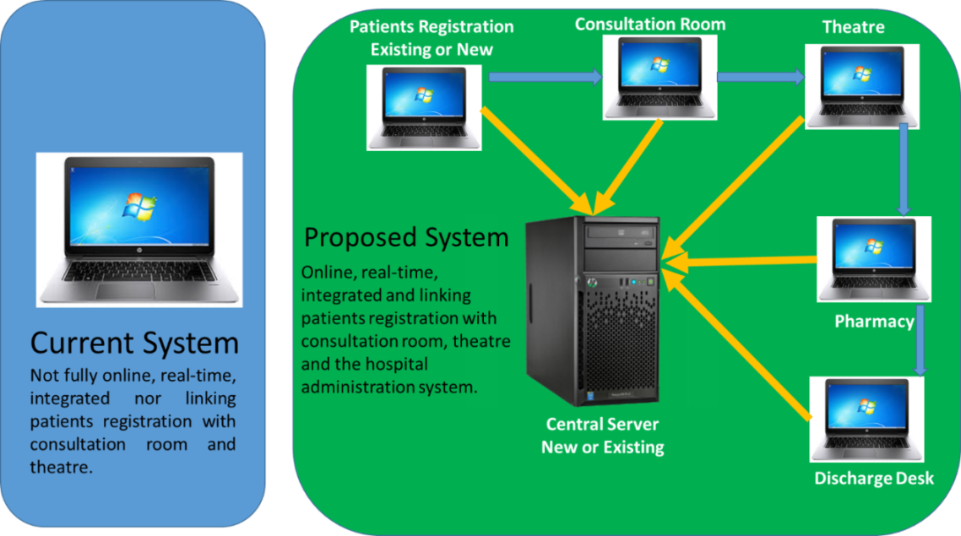
Figure 14: Illustration of the current and proposed SIB upgraded system.

Source: SiB Evaluation Data, June 2017

- OPNs and VHWs’ incentives
The SiB Project management should consider strategies for incentivising project staff (Project Coordinators at all the three centres, OPNs and village health workers) so that they give maximum support to the project. In the case of VHWs, supplying shirts, bags & hats will improve their visibility and confidence.

- VHW´s as primary health facilitators.
The use of the VHWs as primary eye health care facilitators was identified as a noble strategy. In order for them to be effective in their work, the following strategies could be considered to strengthen their role in the project:

Firstly, to design a comprehensive training program for VHWs and roll it out in the three provinces.

Secondly, the roles and responsibilities for these VHWs should be clearly defined and communicated in line with the requirements of the Ministry of Health and Child Care. Also to equip them with relevant data collection tools to ensure ongoing monitoring of the activities. Some of the data to be collected could include but not limited to the following: - 1) The number of community awareness meetings; 2) The number of people that attended the awareness meetings; 3) The number of people with eye challenges segregated by age group; 4) The number of people that are ready to undergo the required eye procedures as per SIB requirements. If the VHWs are well capacitated, they can help the project greatly from mobilisation to reporting. They can play a critical role in all the proposed eye camps, by ensuring that enough numbers are mobilised prior to an eye camp being commissioned.

Lastly the project should put in place a monitoring and evaluation mechanism to track the work of the trained VHWs in the communities in line with the project intentions/objectives. For example, OPNs should conduct monitoring visits during community eye health awareness meetings facilitated by VHWs to ascertain the quality of information shared to the community members.

- Strategies for achieving the outstanding targets.
The SiB project should consider the following strategies to achieve the outstanding targets within the remaining timeframe:

- The number of eye camps should be increased as they have proved not only to be efficient, but are also an effective way of reaching out to more people including those that are economically vulnerable since these have lower costs.
- At Sakubva eye Hospital, the project should consider getting another Ophthalmic Doctor to complement the current Doctor who can no longer cope with demand. The suggested assistant Ophthalmic Doctor could also support the eye camp program.

- Involvement of Community Traditional and Religious leaders
If the project is to be effectively reach out to many people as well as to address traditional harmful eye care practices, consider involving the community gate keepers (Kraal Heads, Chiefs, Religious Leaders, Business People and other influential community leaders) to strengthen inclusive project approach. Such an approach will help increase community acceptance and ownership and this could also increase the number of people demanding for services. Furthermore, the number of people using harmful traditional practices can also be reduced greatly as people will become more enlightened.

- Renovations at Sakubva
Further refurbishments/modifications are still required at Sakubva Hospital. The two theatres (Maternity and Eye theatres) should be totally separated by creating a separate entry points. This proposal will reduce interference and improve privacy when services are offered in the two theatres.

- SKH Referral Challenges
While use of SKH is providing quality eye care services for the children, the challenge is that some people who come far away from Harare and are poor find it difficult to raise money for transport, accommodation and food when they bring their children for eye care services. Therefore, it is recommended that MoHCC should look into establishing referral paediatric eye care hospitals in other parts of the country towards strengthening inclusivity in health care delivery.

- IEC materials
In relation to the IEC Materials, the SiB project should consider the following:
- The distribution of the materials should not be confined to health facilities (Hospitals & Clinics), but should also consider other strategic locations such as Shopping centres, Community halls, Churches and any other sites which are frequented by most people.
- The project should consider producing specific IEC materials that will aid VHWs when conducting their community awareness meetings and trainings. Such materials should be big enough so that larger audiences can see with ease when in a workshop setup.

Project starts on 1st October 2014 ends on 30th September 2017 (see Seeing is Believing – Project Proposal in the Project Summary section, page 1)
14 VHWs interviewed were not trained for SiB Project
www.raosoft.com/samplesize.html
Note that the cost per patient analysed here does not include other costs such as salaries of health personnel and other related costs.

