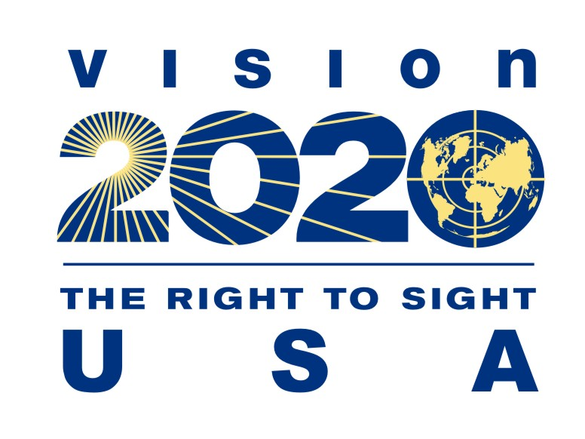

VISION2020/USA Call to Action

to U.S. Surgeon General

Media Guidelines

As we kick off the new year, VISION2020/USA is requesting a Call to Action to the United States Surgeon General on January 18th, 2019 for vision and eye health to mark the year 2020. We’ve had 27 organizations sign on in support of this letter. In keeping with the momentum of this call to action, we include a number of suggestions below to help you get the message across your own individual platforms. We are sure you have more ideas – do share them with us (Pooja Doshi, Vice Chair of VISION2020/USA at pdoshi@iefusa.org) and we will include them on our social media pages as well.

Twitter
- @VISION2020USA launches a Call to Action to improve vision and eye health in the year 2020 @Surgeon_General #V2020CallToAction
- Call. To. Action. @Surgeon_General #V2020CallToAction <url for press release>
- Call your local reps and senators for the #V2020CallToAction to improve vision and eye health @Surgeon_General @VISION2020USA
- #V2020CallToAction aims to improve vision and eye health. Find local reps and senators by visiting https://callyourrep.co/ @VISION2020USA
- Retweet if you support the #V2020CallToAction to improve vision and eye health @VISION2020USA
- Follow @VISION2020USA to stay up to date on the #V2020CallToAction to the @Surgeon_General to improve vision and eye health by 2020

Facebook
- Please Share with your Friends and Family! #V2020CallToAction <insert link>
- Give your local senators and representatives a call to improve vision and eye health by 2020! #V2020CallToAction <insert link>
- Like @VISION2020USA on Facebook to stay up to date on the #CallToAction for the U.S. Surgeon General to improve vision and eye health #V2020CallToAction <insert link>

