Granting permissions
Log in to the online version of egnyte at docs.iapb.org
Navigate to the folder you want to change:
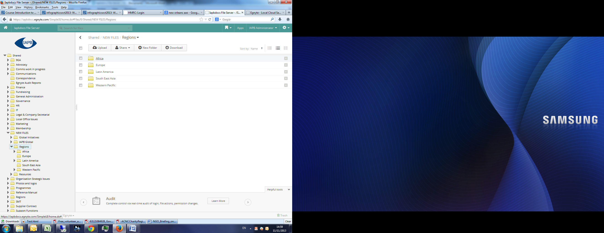
When you are in it choose share from the top menu:
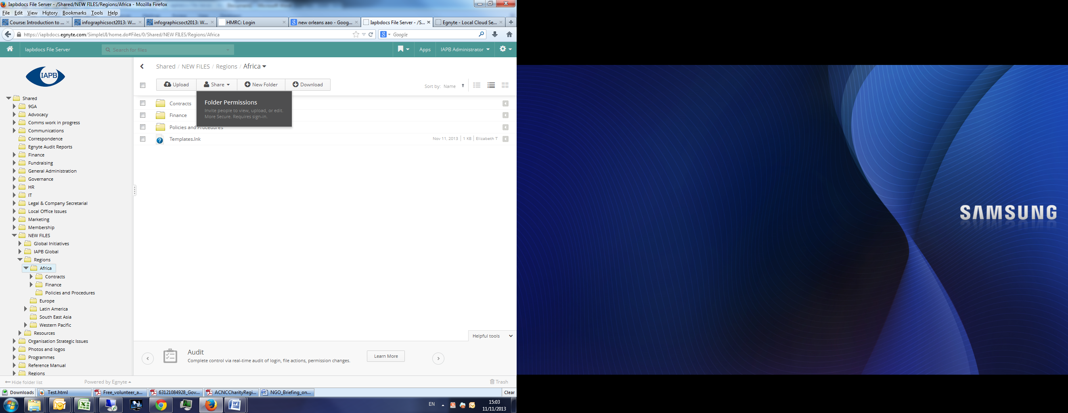
If you are the owner you can add people or groups to be able to view or edit the folder:
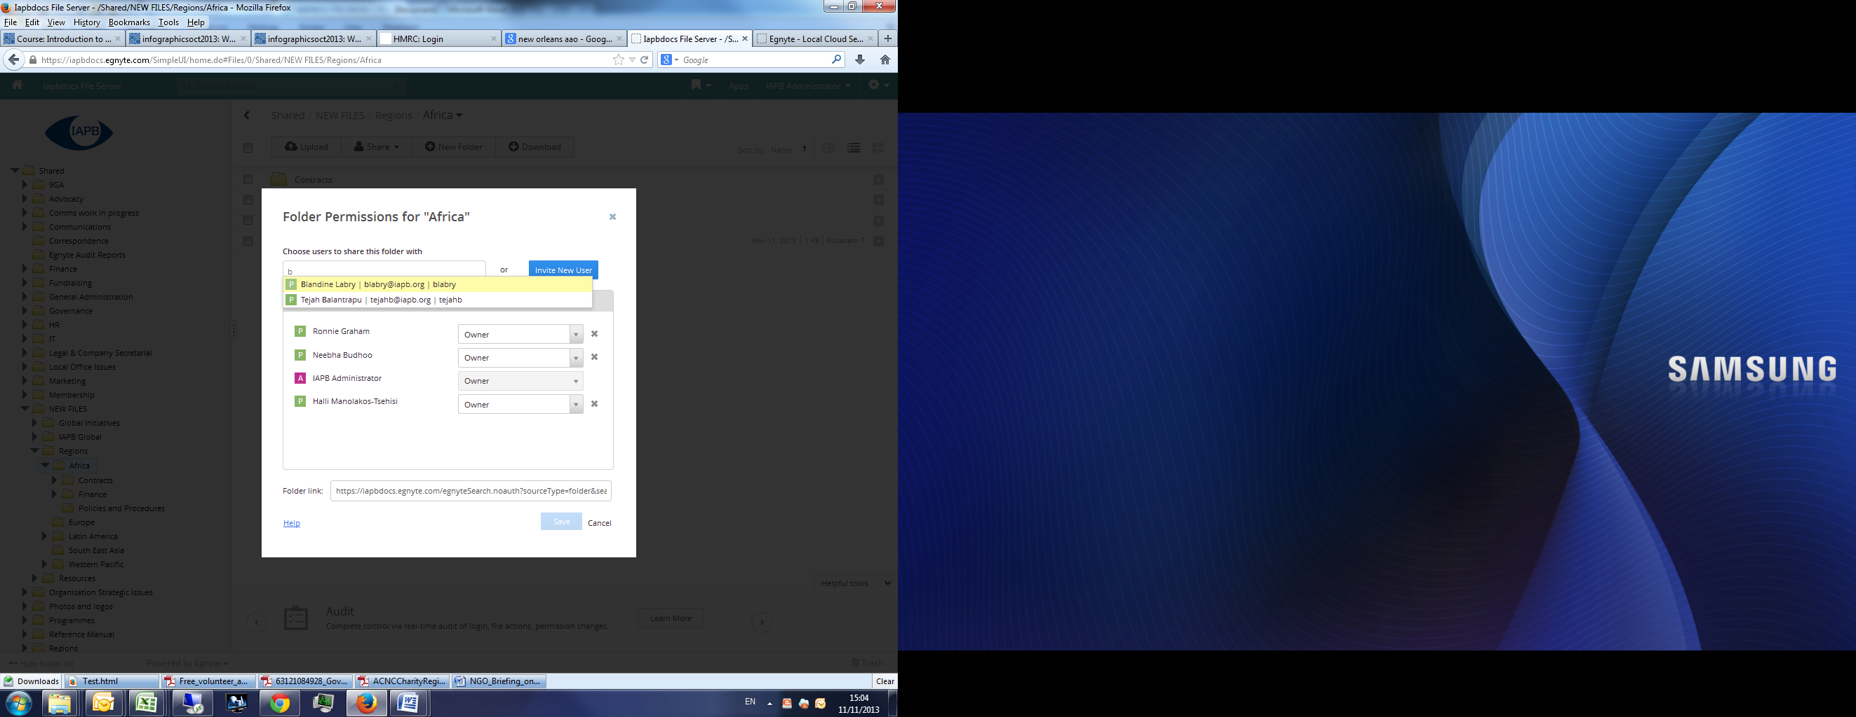
Users can set a four different levels:
- viewer (be able to see and download files)
- editor, see files and add new ones
- Full user, read write, edit and delete files
- owner who can do all of the above and also manage permissions.
If you want to give access to all IAPB staff, you can choose the group ‘All IAPB users’ rather than adding everyone individually. If you want other groups set-up do let us know as these are easy to do.
Anyone added to a folder will automatically have the same access to the sub folders within that folder, both for existing ones, and any ones subsequently created.
If you do not want a user to have access to a sub- folder (or to have different access) you can removed them by following the same steps on that folder.

Sharing files with non-staff
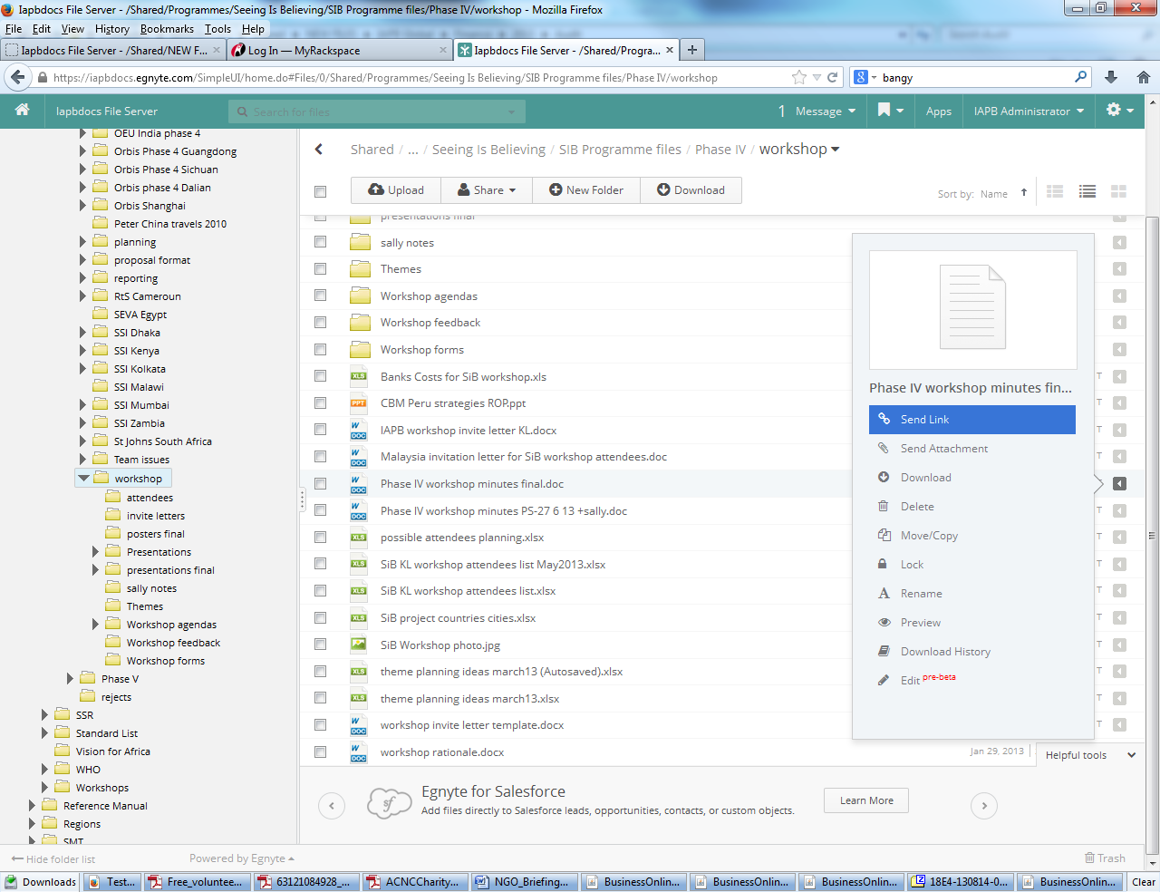
You can share individual files with non-staff, if you click on the grey arrow to the right of a file and chose send link:

You can password protect the file or give free access to anyone who has the link, you can also specify how long the link stays open:
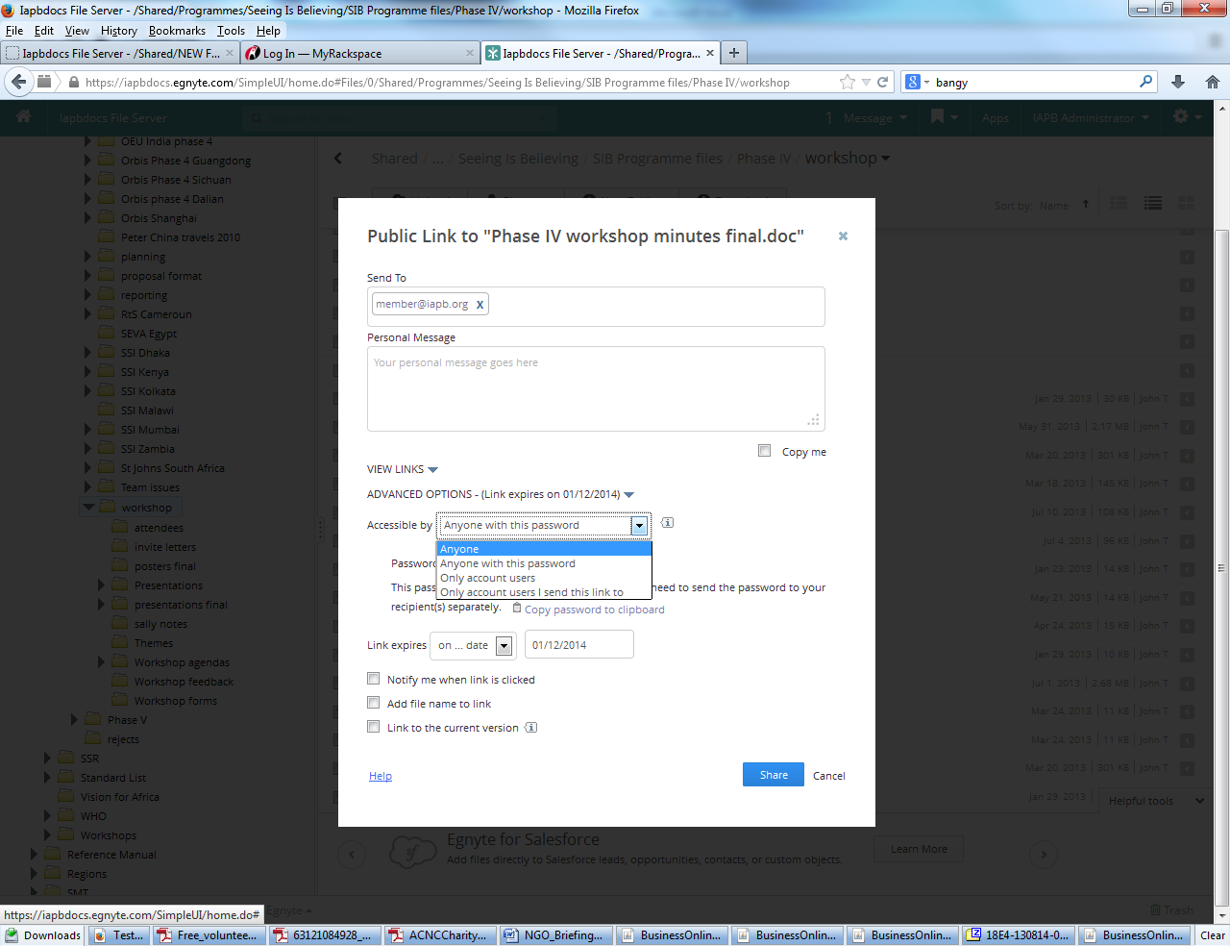

For security reason you cannot share folders in this way, however if you wish to share a folder with non-staff this is still possible please get in touch if you want to set-up a workgroup folder and I will take you through that.

