Mass Drug Administrations (MDA) in the context of COVID-19: A resource document on how to implement WHO guidance for neglected tropical disease (NTD) programs

DRAFT 1: A living document, version August 4, 2020

Prepared by USAID’s Act to End NTDs | East and Act to End NTDs | West programs

Acknowledgements
This document was prepared by a project-level working group that included Molly Adams, Stella Agunyo, Sharone Backers, Margaret Baker, Endri Budiwan, Mawo Fall, Diana Lu, Belete Mengistu, Upendo Mwingira, Betty Nabatte, Benjamin Nwobi, Ukam Oyene, and Elizabeth Sutherland.

We would also like to acknowledge the detailed review and feedback provided by others on Act to End NTDs | East and Act to End NTDs West teams.

Table of Contents
RATIONALE AND BACKGROUND 3
1. Coordination 3
1.1 Coordination with COVID-19 Response Teams 3
1.2 Coordination within MoH 4
1.3 Coordination with other partners actors 4
2. Communication 4
2.1 Before and during MDA: communication with the community 4
2.2 After MDA: communication with the community 5
2.3 Addressing rumors and misinformation 5
3. Training 6
3.1 Virtual training 6
3.2 In person training venues 6
4. Drug Distribution - Planning and Implementation 8
4.1 Health worker and drug distributor precautions 8
4.2 Household MDA 8
4.2.1 Standard protocol upon arrival 9
4.2.2 Treatment of adults and children able to swallow tablets 9
4.2.3 Treatment of children 10
4.3 School based MDA 10
4.3.1 Standard protocol at the start of the activity 11
4.3.2 Treating the children 11
4.4 Fixed/static point community MDA 12
4.4.1 Set up before the community arrives 12
4.4.2 Administering medication 13
4.5 Infection control during data compilation 14
5. Supervision 15
5.1 Infection control measures related to supervisors 15
5.2 Ensuring COVID-19 SoPs are being followed 15
5.3 Virtual supervision 15
6. Documenting, learning, and adapting 15
Appendix A. Checklist to use during training 17
Appendix B. Checklist to use during supervision 19
Appendix C. Guide on how to wash hands 20
Appendix D. Guide on how to wear mask 21
21

RATIONALE AND BACKGROUND

Mass drug administration (MDA) involves administering medicines to community members for preventative treatment of neglected tropical diseases (NTDs) including schistosomiasis, lymphatic filariasis, onchocerciasis, trachoma, and soil-transmitted helminthiasis (STH).

NTD programs distribute medicines to eligible populations using several delivery platforms. Primarily:
- School-based distribution, typically targeting school-aged children (SAC).
- Community-based distribution. This can take the form of either door-to-door/household distribution, or in a central place within the community (e.g. community center, place of worship, market, home of a community leader or medicine distributor), or a combination of the two.

During this unprecedented time of COVID-19, and as programs are re-starting field activities, adjustments are needed to ensure implementation is safe for health care workers and communities. WHO published interim guidance on July 27th, 2020 that aids health authorities, NTD program managers, and supporting partners on deciding when to start activities and precautionary measures that should be put in place?
This resource document complements the WHO guidance. Firstly, it reiterates guidance on precautionary measures to consider when planning for re-start; secondly, it provides ideas and examples on operationalizing the guidance so that it can be applied to field activities. It is designed as a resource for national NTD programs as they develop their own country specific SoPs and should be adapted to country-specific contexts. E.g. adaptations to local situations could include following national guidance on mask wearing.
The guidance and examples contained in this document were led by in country staff and are based on lessons learnt from experience with Ministry of Health-led NTD programs supported by Act to End NTDs | East and Act to End NTDs | West and build on materials developed by other partners including Ministries of Health, the Task Force for Global Health (TFGH) and ASCEND.

Coordination
Effective coordination with other programs and sectors, including COVID-19 Taskforces or their equivalent, will be very important to ensure coordinated messaging and responses.

1.1 Coordination with COVID-19 Response Teams
- Liaise with relevant COVID-19 task forces at all levels of program implementation.
- Advocate for provision of guidelines, protocols, and resources for safe implementation of health care services that include NTDs.
- Tap into resources that might be of help during MDA implementation, such as provision of handwashing facilities, masks, human resources for monitoring implementation, and SOPs.
- Look for opportunities to promote use of COVID-19 testing at the local level. Can also coordinate with mobile COVID-19 labs to attend MDA times.

1.2 Coordination within MoH
- Liaise with the relevant health authorities to make provision for suspected COVID-19 cases detected during the planned NTD activity.
- Review recent experiences of working in the community with other public health programs e.g. malaria and immunizations. What went well? What difficulties did they encounter?
- Consider integrating district-level NTD program COVID-19 messaging with the messaging of similar programs.
- Leverage existing committees such as NGDO coalitions and NTD Steering Committees meetings to develop and adapt protocols, share experiences of implementation, and to mobilize and train workforce.
- Use NTD annual review meetings at national, district and sub district levels as well as other platforms managed by Ministry of Health and Primary Health Care, to share experience and best practices.
- Make use of MoH security guidelines, protocols, and updated information on COVID-19 cases and emerging clusters.

1.3 Coordination with other partners actors
- Involve partners, nongovernmental organizations, civil society organizations, community and opinion leaders, international health agencies and donors.
- Liaise and build synergy when necessary with the UN Office for the Coordination of Humanitarian Affairs (UN OCHA) and UN High Commissioner for Refugees (UNHCR), humanitarian workers/NGOs and other refugee and humanitarian response agencies to adequately address needs of refugees and internally displaced persons.

2. Communication
In this new COVID-19 environment, there will be higher demand for information - on the risk of being infected by COVID-19, on NTDs, and on how programs are being implemented differently to ensure protection of service providers and the beneficiaries.

2.1 Before and during MDA: communication with the community
Communication and messaging on MDA, including where and when MDA is to be held, eligibility criteria, side effects, contact persons, etc. will still need to be done. Additional information on changes due to COVID-19 will need to be incorporated in the messaging. Channels of communication will need to be reviewed to suit the current situation and to build trust with the message recipients.
- Understanding the community before going in to do activities is important. As always, include trusted local leaders in planning activities and seek to avoid other major community events.
New communication messages
- It is safe to receive and take medicines for NTDs during MDA because safety measures have been put in place.
- Community members over 60 years old and with pre-existing health conditions including diabetes, high blood pressure, cancer, heart diseases, and respiratory infections are most at risk of having severe forms of Covid-19. Additional measures should be taken to reduce their exposure to potentially infected persons.
- Persons with a higher risk of transmitting infection should not participate. This includes persons with symptoms, persons living in same house as known COVID cases, persons who have arrived in the last 14 days from areas with known higher infection.
- Messages explaining how MDA will be different this year. This will vary between activities, distribution strategy and locations. Examples include:
  - Information on how to queue in a line and maintain social distancing (two meters between each person).
  - The need for households to provide water for drug distributors to wash hands.
  - Medicines will be given outside houses.
  - Assurance that all drug distributors will be wearing face masks.
  - The need for household members to always stand at least 2 meters apart from MDA team.
  - Requests for recipients to bring their own drinking cup and possibly also drinking water.
  - To wear masks - depending on guidance provided by local / national authorities
  - Measures being taken to ensure safe dispensing of medicines.
- Emphasis that preventative measures should be applied during MDA and other events to prevent spread of COVID-19 in the community.
- Any information obtained on suspected and/or new COVID-19 cases in the community where MDA is taking place should be communicated per advice of the COVID-19 task force in the area/district. Decisions will be made on whether to continue or stop MDA during NTD program contact with communities.
Means of communication
Radio, TV and use of town announcers, megaphones remain safe modes of communication. Face to face communication with households and large gatherings should be reduced or avoided.
When communicating in person with community leaders and schoolteachers, wear masks and maintain the 2m social distance.

2.2 After MDA: communication with the community
- Hold feedback session with community leaders – keep group numbers small, maintain safe distancing of 2 meters apart, meet outside where possible, and follow local guidance on mask wearing.
- Hand washing facilities and/or sanitizers should be readily available at the venue of every meeting
- Listen to community leaders’ and community members’ comments and opinions on MDA, commend them for their active participation, discuss the coverage and how gaps need to be addressed.
- Stress the need for continual adherence to prevention methods against COVID-19
- Discuss and agree on follow-up actions

2.3 Addressing rumors and misinformation
Misinformation on the pandemic can be problematic. Negative rumors could harm the MDA if not addressed. A system should be put in place to identify and manage rumor and misinformation before, during, and after completion of MDA round.
- Report any rumors related to COVID-19 during drug distribution to appropriate authorities in the community, including the COVID-19 taskforce, local MOH authorities, and NTD program manager.
- Appoint a staff member at state/district level to conduct news media monitoring (including social media if relevant), analyze and disseminate timely information for necessary action to be taken.
- Listen to the community to better understand rumors and empower the community to make informed choices.
- Use a source or persons trusted in the community to dispel rumors.

3. Training

3.1 Virtual training
The preferred method of trainings during the pandemic is virtual– especially when trainers live in different parts of the country. Live web-based training can be used where internet connection is good. Other options include recorded trainings and FAQ which can be distributed via CD, USB, and training via mobile application for those who have access to smart phone internet connection. Virtual training has not been the norm and some experimentation will be needed to find methods that work.

3.2 In person training venues
Additional Equipment List
- Masks for all participants and trainers
- Disinfectant for wiping surfaces
- Handwashing water and soap or hand sanitizer
- Disposable paper towel
- Dust bin
- Signs and symptom checklist for screening of all participants (see box 1)
Conducting Training:
- The head trainer or a supervisor should screen (see box 1) the trainers and trainees upon arrival to the training, for every day of training. Should someone have symptoms or exposure to risk, they should not participate in the drug delivery.
- Consider excluding from training, and subsequent MDA distribution, any persons who are at increased risk of COVID-19 including those over 60 years and those with pre-existing medical conditions.
- Avoid (or minimize) delays between training and field implementation. Activities should start shortly after the training (preferably within a day) to avoid additional travel to and from the field which provides additional opportunity for COVID-19 transmission. Therefore, have ready all materials (e.g. drugs, pamphlets, Job Aides), cloth masks and personal protective equipment (PPE) before commencing training.
- Trainers and trainees should always be wearing masks and practicing social distancing.
- The space must be able to accommodate everyone with 2m in between, outdoors is preferred. If indoors, ensure it is well ventilated.
- Wash stations should be made available at every training. Trainers should explain to all trainees how to wash hands appropriately and all attendees should wash their hands upon arrival and wherever appropriate during the training (i.e., when touching a contaminated surface, when returning to the training venue from another location).
- Eating should be avoided in the training room if possible.
- At the end of each day, equipment should be disinfected.

Box 1. Implementing MDA in a COVID-19 context requires screening for signs and symptoms of the virus. The below information is from WHO guidance on MDA restart during COVID 19 item 3.6.

COVID-19 Screening
1 | Symptoms suggestive of COVID-19:  - fever (if not measurable, consider self-check)  - visibly apparent symptoms such as cough, shortness of breath, nasal congestion, and red eyes
2 | Exposure to risk:  - contacts of COVID-19 cases and of people with symptoms suggestive of COVID-19 (e.g. those living in their same household)  - in the case of activities implemented in areas without known/suspected community transmission, also people coming from countries or areas with known/suspected community transmission of COVID-19 less than 14 days before may be added
3 | If screening is positive:  - exclude the individual from the NTD activity  - offer a medical mask  - advise to follow relevant national guidance on COVID-19  - consider identifying an isolation space or room at the activity site for people screening positive who cannot leave the site immediately.

Additional COVID-19 curriculum
- NTD health workers should be trained in the common signs and symptoms of the COVID-19 virus and receive information on their local referral system in case they come across a likely case in the community.
- Drug distributors should be trained on COVID-19 infection control during the usual pre-MDA training. In addition to covering all normal aspects of the NTD(s) being targeted in specific areas, training should also include content on how distributors can protect themselves and their community against the COVID-19 virus.
  - Specific instructions should be given on how to wash or sanitize hands, wear a mask, practice social distancing, report cases, and communicate to communities and households.
  - Participants should also be given the opportunity to practice these during training e.g. by role playing.
- NTD health workers should be trained in the common signs and symptoms of the COVID-19 virus and receive information on their local referral system in case they come across a likely case in the community.

See Appendix A for training checklist

4. Drug Distribution - Planning and Implementation

4.1 Health worker and drug distributor precautions
- During planning, the number of persons in a team and the number of households to be covered in a day should be reevaluated to take into consideration these new measures which could be more time consuming.
- All drug distributors should have been trained on MDA, infection control measures specific to conducting MDAs, and COVID related topics.
- If any staff or drug distributor feels unwell at any time during MDA, or is in close contact with a COVID-19 case, they should inform their supervisor, stop work immediately, and follow local guidance for persons with symptoms (see Box 1).
- Masks should be worn over the nose and mouth by distributors all the time. If masks must be removed temporarily to speak clearly, 2m social distance should be strictly maintained. Field experience suggests planning on two masks per distributor.
- Drug distributors who work in groups should keep groups small and remain with the same group throughout the MDA exercise to reduce exposure.
- Drug distributors should avoid eating or drinking at the homes they visit.
- Drug distributors should carry their own hand sanitizer and clean hands in between every household seen. Field experience suggests planning on one bottle of 300 ml of hydroalcoholic gel per distributor per week.
- Drug distributors should dispense medicines to household members outside (e.g. in the compound) and not inside the house, to allow for maximum ventilation.
- Materials like pill spoons and dosing poles should be disinfected/washed at the end of each working day.
- Maintain regular contact with field locations, understand cultural issues and political situations.
- Maintain regular contact with supervisor including communicating progress towards achieving MDA targets, communicating about what is working well, and challenges operating amidst COVID-19, so adaptation in real time is possible.
- Pay attention to new COVID-19 outbreaks in the local community and make timely and informed decision as required, following local COVID guidance.

4.2 Household MDA
Household based MDA (i.e. door-to-door) is currently preferred to fixed point MDA as social distancing can be managed more easily.

Minimum additional materials:
- Handwashing water provided by household (carry sanitizer where this is not feasible)
- Soap
- Drinking water for taking medicines and drinking cups (both preferably provided by household)
- Clean plate/bowl/paper provided by household (for placing medication)
- Dose poles (these can be marked at 1 meter and used to measure distances too)
- Chalk (for marking heights from dose pole)
- Disposable syrup cups for children when applicable
- Masks

4.2.1 Standard protocol upon arrival
- Conduct distribution outside of each home as risk of COVID-19 transmission is much greater indoors.
- The drug distributor, upon arrival at a home, should introduce him/herself outside the door at a 2-meter distance, and explain the purpose of the visit. In addition to routine messages given on NTDs, s(he) should:
  - Note that the drug distributor and household members will remain 2 meters apart at all times
  - Screen for COVID-19 cases (see box 1)
- Young children should be supervised by other household members during the survey to avoid being too close to the survey team and to stop them following the team to next HH.
  - One person on the team should be responsible for ensuring crowds are not gathering as the team moves from house to house

4.2.2 Treatment of adults and children able to swallow tablets
- The medicine distributor should call HH members one by one to avoid crowding around the treatment area.
- The distributor should request that everybody in the household wash their hands with clean water and soap and remain wherever they are, ensuring the 2m distance between them and the distributor. The drug distributors should also wash their hands. Where water is in short supply hand sanitizer can be used instead.
- If height measurements are taken with dose poles, these should be carried out with the household member facing away from the distributor, who can hold the pole while facing the back of the household member, deduce dosage, then step back to 2 meter distance. Alternatively, dose poles can be propped up e.g. against a table, chair or wall. Another alternative is to have CDDs given chalk to mark the dosage heights on an outdoor wall or tree with chalk, using a dose pole as a guide. If these are not possible, the household member should face away from the distributor, who can hold the pole while facing the back of the household member, deduce dosage, then step back to 2-meter distance.
- Try to maintain 2 meters of distance when dispensing medication. HH member can provide a clean bowl/plate/ paper and place this on a table or chair between themselves and the drug distributor, then step back 2 meters. The distributor then steps forward and drops the tablets in the bowl/plate/ paper. (S)he then steps back to allow the HH member to step forward and take the pills. Effort should be made by the drug distributor not to touch the tablets or bowl.
- Water to take medicine should be provided by the household.
- Children can be assisted by an adult HH member and should be advised to chew tablets if needed. They should NEVER force a child to take the medicine and should NOT hold the child’s head and neck back, nor pinch the child’s nose. These can cause choking which can result in death.
- Wash or disinfect dose pole between households
Figure 1 Household MDA with COVID-19 precautions
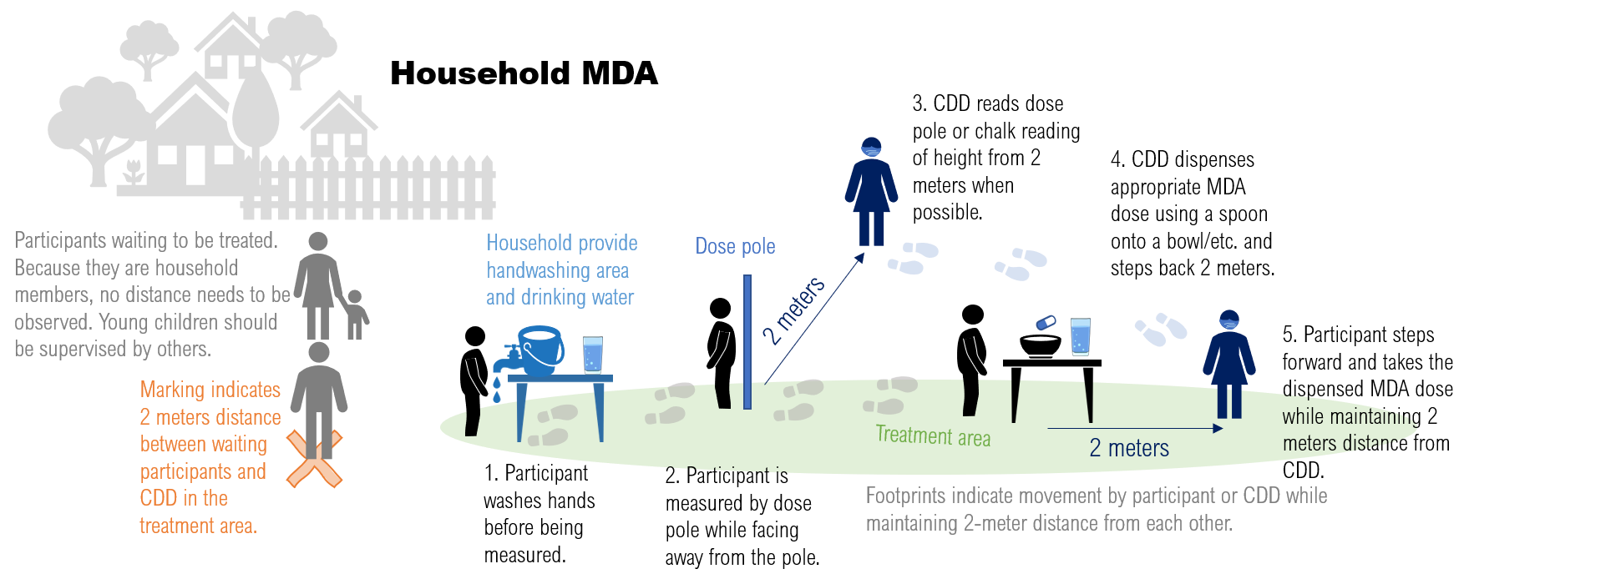

4.2.3 Treatment of children
- The distributor will call out the child by name and request the mother or any other adult familiar with the child to support them as they stand against the dose pole.
- The HH adult can read out the number on dose pole at the top of the child’s head, or the drug distributor can observe it from 2m away.
- The distributor will measure out the syrup and instruct the mother (or other adult) how this is administered, then steps back 2m.
- The mother (or other adult) steps forward, helps the baby drink the syrup without applying force to the child to prevent chocking which can result in death.
- Each child should have his/her own syrup cup which is disposed of as previously planned.
- Record as usual.

4.3 School based MDA
School based MDAs should only be conducted if schools are already open and have established protocols for managing COVID-19 in place.

Minimum additional materials:
- Handwashing water provided by school (carry sanitizer where this is not feasible)
- Soap
- Drinking water for taking medicines and drinking cups (both preferably provided by children/school)
- Clean plate/bowl/paper provided by school (for placing medication)
- Dose poles (these can be marked at 2 meter and used to measure distances too)
- Chalk (for marking heights from dose pole)
- Disposable syrup cups for children when applicable
- Masks

Process/procedures:
These are written assuming teachers are managing MDAs in classrooms. This limits the risk of infection by limiting exposure with new points of contact.

4.3.1 Standard protocol at the start of the activity
- Drug distribution for each class must be handled separately. Medicine is administered by class teacher (or whichever medical personnel is approved by school administered if not teacher) and supported by at least one other adult from within school.
- Schools may consider taking classes outdoors in sequence for distribution.
- The teacher should introduce the activity. In addition to routine messages given on NTDs s(he) should explain the COVID 19 safety precautionary measures that should be followed, including:
  - How things will be set up so that social distance is maintained between the children and teachers. See figure 2 for example of possible set up.
- Mark the dosage heights on a classroom wall with chalk, using a dose pole as a guide.
- If schools require mask usage, all should have their masks in place.

4.3.2 Treating the children
- Before distribution, everyone must wash or sanitize their hands. The teacher should allow pupils to move one by one to the handwashing point after their name has been called out to ensure social distancing. All children must be asked to wash their hands for at least 20 seconds. If this is not possible, use hand sanitizer.
  - Each student should be called up one by one to avoid crowding at the measurement and medicine tables.
- The child should stand against the pre-drawn chalk marks to determine height, maintaining 2m distance
- The teacher should administer the medication and record the tablets/MLs taken in the register.
- Try to maintain social distance when dispensing medication. Student member can place a clean bowl/plate/ paper on a table or chair between themselves and the teacher, then step back 2 meters. The teacher then steps forward and drops the tablets in the bowl/plate/paper. (S)he then steps back to allow the student to step forward and take the pills. Effort should be made by the teacher not to touch the tablets or bowl.
- For drinking water, the child should be allowed to touch the water dispensing tap only after they have washed their hand with soap. Each child should be encouraged to bring their own container/cup for drinking water provided by the school or brought from home. It may be necessary to have disposable cups as back up.
- If a dose pole is used, wash or disinfect dose pole between classes.

Figure 2 School based MDA with precautionary COVID-19 measures in place
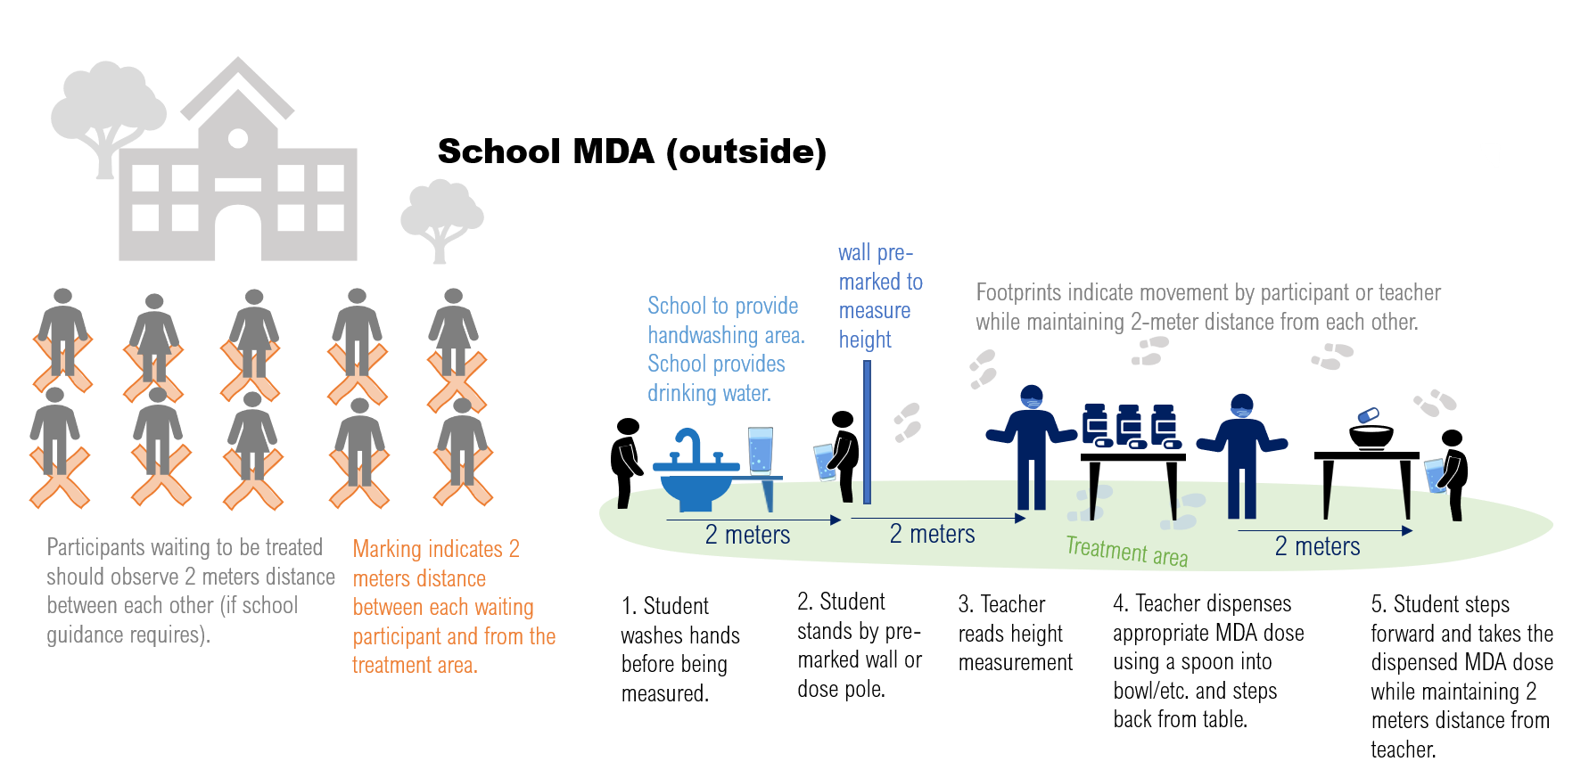

4.4 Fixed/static point community MDA
Fixed- or static-point MDAs require more crowd management than HH based MDAs and pose a greater risk of infection, therefore feasibility of household-based MDAs should be considered first.

Minimum additional materials:
- Hand sanitizer or hand washing water and soap
- Alcohol/bleach-based disinfectant
- Drinking water and disposable cups
- Dose poles
- Small clean pieces of paper on which to lay the medicines
- Spoons to distribute medicines
- Disposable syrup cups for children
- Station signs
- Chalk or tape
- Masks
- Trash bags/ cans

4.4.1 Set up before the community arrives
- Set-up the distribution point with clear marks and signs to include the following (See figure 3 below):
  - Waiting area—may need to be set up in school playground or local administration compound
  - Hand washing or sanitizing station
  - Height measurement and treatment area, with dose pole set up so that it does not need to be held/ touched
    - Treatment observation station with water provided may be separate or included in above
- Each station will need a station manager whose role it is to call people to come forward, to ensure that the maximum number of people allowed at a station is not exceeded, and to ensure distance is maintained. If there is overcrowding, station manager should designate an overflow area or ask individuals to come back at another time.
- Ensure that all persons supporting the MDA distribution, including those managing stations, are wearing masks.
- Each station should have floor marked (using chalk or tape) at 2m intervals (see figure 3).
- Signs should be posted at the entrance to provide information on COVID-19 and on what to expect during drug distribution.

4.4.2 Administering medication
- Megaphones should be used to explain to the people the COVID 19 precautionary measures that will be taken.
- Station managers will call people to come forward. If people are in family groups they can stay together. Station managers will ensure that the maximum number of people allowed at each station is adhered to and that distance between family groups is maintained. If overcrowding occurs, station manager may need to designate overflow area or ask that people come back another time.
- At hand washing station, station manager should ensure everyone washes hands with soap and water for at least 20 seconds or uses sanitizer.
- Drug distributor must wash hands or use hand sanitizer between every household group seen.
- At height measurement and treatment station, if height measurements are taken with dose poles, these should be placed so that they do not need to be held or touched. Then, the person stands with back to pole and number of tables is recorded from distance of 2M.
- Try to maintain 2 meters of distance when dispensing medication.
  - For adults: distributor should have laid out a clean piece of paper on the table that stands between them and HH members. Once dosage is known, the distributor steps forward and drops the tablets on the paper. (S)he then steps back to allow the HH member to step forward and take the pills. Effort should be made by the drug distributor not to touch the tablets and paper should be changed between each HH group.
  - For children: child can be assisted by an adult HH member and should be advised to chew tablets if needed. Assisting adults should NEVER force a child to take the medicine and should NOT hold the child’s head and neck back, nor pinch the child’s nose. These can cause choking which can result in death.
  - For children: The distributor will measure out the syrup / tablets and instruct the mother (or other adult) how this is administered, then steps back 2m. The mother (or other adult) helps the baby drink the medicine without applying force to the child.
- Drinking water should be available to the participants. Participants can be asked to bring their own cups and water. Disposable cups and water can be provided as back up. A trash can should also be available for disposing of the used cups.
- A plan for disposal of waste should be followed at the end of each day and all items wiped down with disinfectant.

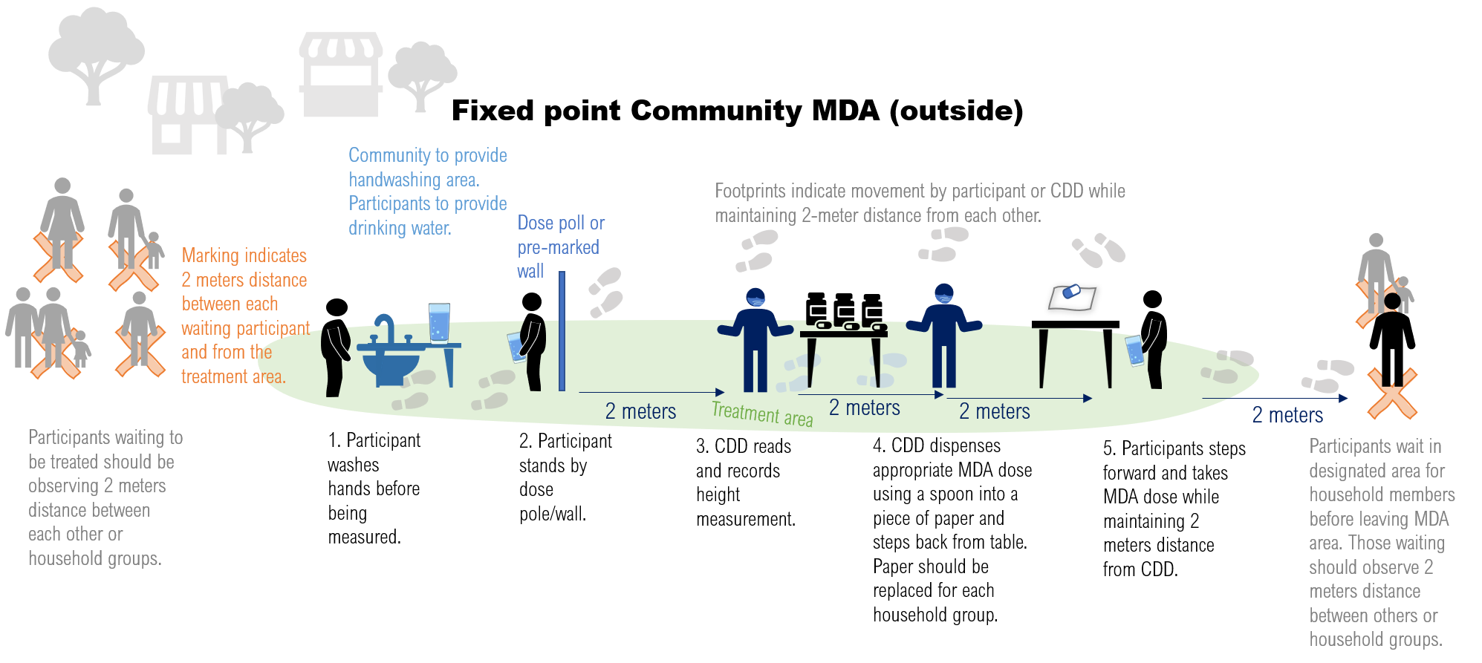
Triage at Static Point MDA Diagram
Figure 3: MDA at static/ fixed point, with infection control precautions

4.5 Infection control during data compilation
Using paper forms
- Medicine distributors should sit 2m apart in small groups of less than ten people to support each other in transferring data from the register to the summary forms. All attendees should be wearing masks. They should select a leader amongst themselves who will deliver the data to the supervisor.
- Medicine distributors should ensure they wash their hands with water and soap before and after touching the registers, tally sheets and pens.
- Pens can be disinfected by using the bleach solution prepared for disinfecting dose poles by pouring a small amount on a cloth/disposable paper towel and rubbing the outer part of the pen and avoiding the nib. Individuals should use their own pens whenever possible.
- Instead of wetting fingers with mouth to flip pages, a water-soaked cloth should be used instead.
- Supervisors also need to wash their hands with water and soap before and after they receive the summary sheets from the village, and before and after summarizing the data into the subdistrict forms.
- The same procedure should be followed during data transfer from the sub district to the next levels.

Using electronic data capture
- Hand washing with water and soap should be done before and after touching the data collection tablets.
- Sharing of the tablet should be minimized as much as possible. When tablets are shared, data collectors should wipe with disinfectant before handing it over to the next person.

5. Supervision

5.1 Infection control measures related to supervisors
- Supervisors should follow the same infection control measures as drug distributors (see section 3.1 above).
- In-person MDA supervision should be delegated to local supervisors as much as possible. If district or national level supervisors must be brought in, they should not come from areas with higher COVID-19 infection risk and risk control measures should be taken during travel.

5.2 Ensuring COVID-19 SoPs are being followed
- In addition to routine MDA supervision, supervisors should ensure that SoPs related to COVID are being followed. See Appendix B for additional items that can be added to a supervision checklist.
  - When the supervisor observes something that is not correct, they should provide feedback to the drug distributor so that the issue can be corrected.
  - They should also summarize issues being addressed as part of regular feedback to their supervisor during MDA, highlighting any high priority concerns for district- and central-level staff.

5.3 Virtual supervision
- District and national level supervision may be virtual. Virtual supervision methods include:
  - Group chats like What’s App can be used during MDA to share observations and advise during MDA between distributors and supervisors.
  - Field based staff can share photos and videos (of ongoing social mobilization, workshops, training, field and mass campaigns) taken with phones. Supervisors can check for adherence to correct mask wearing and social distancing.
  - Frequent (e.g. daily) calls to field-based supervisors can be made to check in on coverage, whether SoPs are being followed, and to discuss any issues that arose that day. Supervisors should follow up on actions arising as needed.

6. Documenting, learning, and adapting
As the whole world looks to adapt MDAs to the new COVID-19 environment, the rapid sharing of key lessons learnt and recommendations should be prioritized.

In addition to the immediate sharing of information that allows real time changes to be made DURING MDA (see supervision section above), it will be helpful to document and share more widely lessons learnt. There are a few ways that this can be done:

- Post-MDA review meetings.
  - These are usually held after MDAs and should be adapted to include capturing COVID-19 related learning. What worked well? What new challenges arose? How were these managed? How did costs differ compared to pre-Covid operations? Notes taken during the meeting should be included in post-MDA reports and made available for future learning and adapting exercises.
  - These may be held virtually. If in person, the same infection control measures outlined under training section above should be followed.
- Supervisor reports.
  - Supervisors should submit a short end-of-MDA report that includes observations and lessons learnt on operating under COVID-19, including during meetings with leaders, planning, training, MDA, and post MDA activities. Observations can include documenting the changes made as well as any challenges faced, solutions found, and recommendations made. See Figure 4 below for an example form that can be used or modified.
  - Completed forms can be summarized and synthesized at district and again at regional/ national level with key learnings and recommendations for planning and future activities shared in post MDA review and other meetings and saved for future access.

- Program level synthesis and sharing of learning. National programs will want to synthesize, document, and share lessons learnt. This includes:
  - Quick sharing of photos and stories (e.g. via Twitter, Instagram, on websites, and in blogs) from the field that illustrate adaptations being made
  - Post MDA reports that include a section on learning from COVID. Under this section material documented in supervisors’ reports, post MDA review meetings, and from other sources can be brought together and summarized.
  - These should then be summarized and synthesized at district and / or national level with recommendations for planning and future activities shared in review and other meetings, group chats, blogs, tweets, etc.

Figure 4 Form for supervisor's documentation of learning during COVID
Time period | Description of relevant learning and adaptations
Pre-MDA
(include planning and training)

During MDA implementation

Post-MDA

Provide your top 1-2 recommendations for future activities

If you have any feedback on this document or recommendations for future versions, please email acteast@rti.org.

Appendix A. Checklist to use during training

MDA Training Checklists during COVID-19 |  | Yes/No | Comments
Pre-training checklist
1 | Is the venue large enough to accommodate the intended number of participants with 2m between?
2 | Are seats, benches, or desks arranged 2m apart?
3 | Is the venue well ventilated? Are windows and doors functioning well and are open?
4 | Is the venue marked to limit access of unauthorized personnel?
5 | Is the venue cleaned and disinfected with standard cleaning and disinfectants before participants arrive?
6 | Is shared bathroom cleaned and disinfected at the beginning of the day and again at midday?
7 | Is there a washing area set up and equipped with adequate supply of water and soap at the beginning of the training?
8 | Is there a focal person assigned to monitor all hygiene and sanitation supplies and activities during the event?
9 | Is adequate alcohol-based sanitizer available in areas where water is scare?
10 | Is every attendee wearing a facemask? Is the mask worn properly (covering nose and chin)?
11 | Is there a focal point assigned to manage screening? Do they have a COVID-19 signs and symptoms checklist available to them (see box 1)?
12 | Is there an area designated for COVID-19 screening upon arrival?
13 | Is adequate alcohol-based sanitizer available in areas where water is scare?
Post-training checklist
1 | Is the venue cleaned and disinfected with standard cleaning and disinfectants at the end of the day?
2 | Is shared bathroom cleaned and disinfected at the beginning and end of the day?
3 | Were all materials and equipment disinfected after each use?
4 | Did participants wash their hands with soap or use hand sanitizer properly as they went out and returned to the venue for any reason?
5 | Were disposable masks properly disposed of in the waste bin after the training?
6 | Was every participant screened for signs and symptoms of COVID-19 using a checklist and thermometer before entering the venue?
7 | If a participant reported COVID-19 symptoms, were they managed following local guidelines?

Appendix B. Checklist to use during supervision

MDA Supervision Checklists for COVID-19 |  | Yes/No | Comments
Pre-MDA CDD check-in
1 | All CDDs had received trained on COVID-19 prevention measures
2 | CDDs were screened for illness and no sick person was allowed to work
Observation at household
1 | Treatment was done outside
2 | CDDs always wore facemasks
3 | 2 meters distance was maintained between HH and CDDs at all times
4 | CDDs washed hands thoroughly on entry and leaving
5 | CDDs at HH were all of same family or kinship group
6 | Appropriate communication was given to HH on entry, including Information on COVID-19 safety precautionary measures and how those would be applied during this visit.
7 | A clean and dry plate was provided by the family members for handling tablets
8 | The CDD did not touch the tablets with their hands
Comments on what worked well and/or problems that arose:

Appendix C. Guide on how to wash hands
Example of hand washing guidance (can replace with material developed in country).

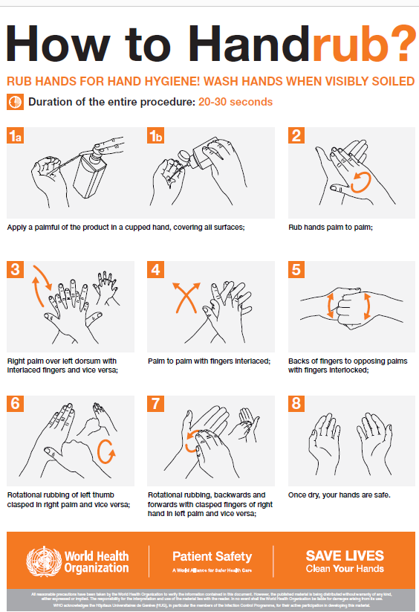
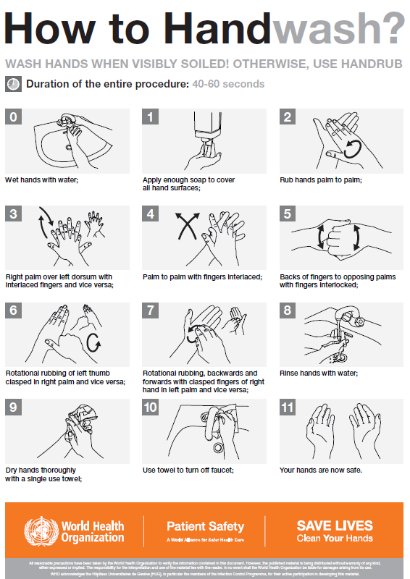

This image is from Save Lives, Clean Your Hands Campaign, WHO. 2009. Unpublished.

Appendix D. Guide on how to wear mask
Example of mask wearing guidance from WHO (can replace with material developed in country)

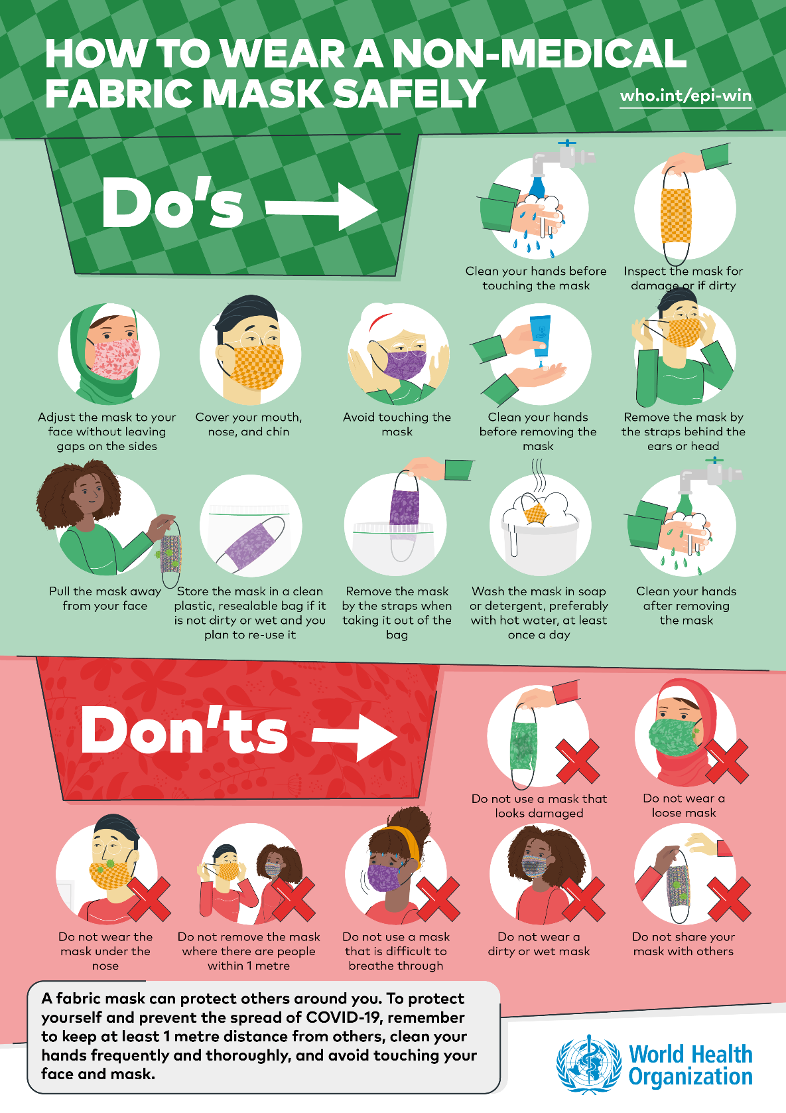

This image is from Coronavirus Disease Advice for the Public: How to Wear Masks. WHO. 2020.

WHO. Considerations for implementing mass treatment, active case-finding and population-based surveys for neglected tropical diseases in the context of COVID-19 pandemic. Interim Guidance. 27 July 2020
WHO. Considerations for implementing mass treatment, active case-finding and population-based surveys for neglected tropical diseases in the context of COVID-19 pandemic. Interim Guidance. 27 July 2020

