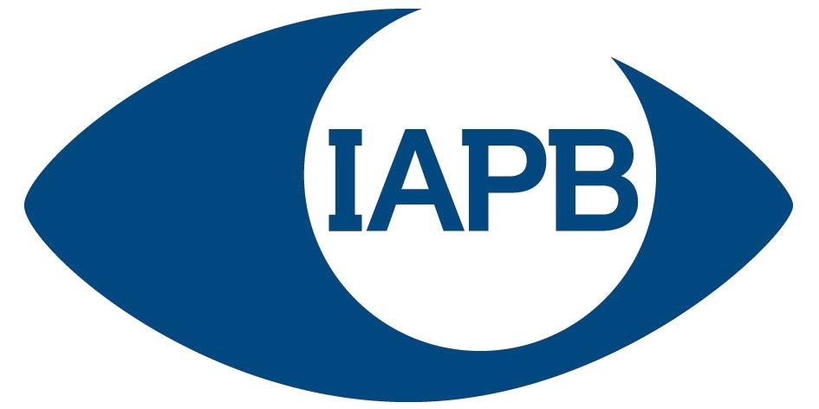

JOB DESCRIPTION

Job Title: Communications Officer: Media and Digital

Job Location: Global

Line Manager: Communications Manager

Expected Salary Band: £28,000 – £35,000
Adjusted to role-equivalent in selected candidate’s country of location.

JOB PURPOSE: Briefly describe the overall purpose or function of the job

The Communications Officer: Media and digital is a key role with the IAPB Communications team, working with the Communications Manager and the Head of Communications on IAPB’s digital platforms and media relationships. The Officer will work on four broad areas: Social media management, media relations, campaigns and team support. They will be part of an international team of communications professionals delivering on IAPB’s key campaigns and programmes throughout the year.

MAIN ACCOUNTABILITIES:

1 | Social Media  - Run IAPB’s social media activity in consultation with colleagues and the Communications Manager, including building and managing the monthly schedule.  - Ensure that social media posts and responses are timely and relevant, and match with IAPB’s overall communications strategy and specific project objectives.  - Work with design colleagues to develop content for IAPB’s social channels including social media tiles, GIFs, videos etc.  - Produce regular reports on social media performance.  - Monitor effectiveness, cost and opportunities across all SM channels  - Monitor and advise on which channels IAPB should be using, for which audiences and measuring success.
2 | Media and public relations  - Write and Edit Press Releases, Statements and Website articles for IAPB to an extremely high standard.  - Research and maintain a database of IAPB’s network of media contacts using available media monitoring services.  - Manage IAPB’s media monitoring service and send out press releases using the relevant databases.  - Support the Head of Communications in media outreach and material preparation, including press releases, publishing them on the website etc.  - Support the Head of Communications maintaining engagement with key media contacts and influencers to advance IAPB's communication goals.  - Weekly monitoring of news in the sight sector, sharing relevant insights with the internal team.  - Represent IAPB at external meetings.
3 | Admin support  - Maintain a future-facing communications grid across all of IAPB's channels and outlets.  - Manage the general communications inbox, including stock responses and re-directing queries to relevant team members.  - Support with the internal publishing process, including proofing, basic copy-editing, drafting and publishing content on the IAPB websites etc.  - Writing reports on work and updating the wider team on the work on the Communications Team.
4 | Campaigns and Events  - Support the Head of Communications and Communications Manager with the development of campaigns and events especially around World Sight Day.  - From time to time assisting with IAPB events.

JOBHOLDER ENTRY REQUIREMENTS: In a series of brief statements identify the essential knowledge, skills and behaviours required.

(E) Essential, (D) Desirable

The role requires someone who is able to use their initiative to juggle competing priorities and stick to tight timelines in order for the whole team to achieve its goals.

Knowledge & Experience:

Good understanding of approaches to social media covering all the main channels. (E)
Good understanding of media and public relations (E)
Qualified to degree level or with equivalent experience (E)
Knowledge of health or development issues (D)

Skills (Special Training or Competence):

Excellent verbal & written communication skills (E)
Excellent drafting skills. Able to tailor written communications to a wider variety of different audiences. (E)
Strong social and digital content general skills. (E)
Well organised (E)
Good IT skills (E)
Basic project and event management, including logistics (D)
Experience of running media management services (D)
Knowledge of a range of web tools (D)
Knowledge of design platforms like CANVA and/or Adobe Illustrator (D)

Key Behaviours:

Positive attitude with the ability to work well in a team and on their own.
Creative. Good at generating imaginative ideas.
Attention to detail and problem solver.
Sensitive to working in different cultural settings and to the divergent interests of partners.
Strong collaborative team player.
Self-motivated. Gets things done.

OTHER COMMENTS

There may be some limited overseas travel.

Dated: November 2021

